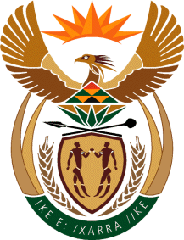
MINISTRY: SPORT AND RECREATION
REPUBLIC OF SOUTH AFRICA

Private Bag X869, Pretoria, 0001, Tel: (012) 304 5158, Fax: (012) 323 8426
Private Bag X9149, Cape Town, 8000, Tel: (021) 465 5506/7/8/9, Fax: (021) 465 4402

Parliamentary Question to the Minister

3690. Ms D Carter (Cope) to ask the Minister of Sport and Recreation:
Whether, with reference to a certain study regarding South African rugby (details furnished), his department is working closely with the Department of Basic Education in order to ensure that resources are equitably distributed to all schools and that Springbok rugby players do not only come from the so-called elite schools; if not, why not; if so, what steps (a) has his department taken and (b) does his department intend to take in collaboration with the Department of Basic Education to promote and inculcate a culture of sport and rugby from an early age with a view to transforming the sport of rugby, to achieve the ideal of non-racialism and equality in sport and to free the potential of all of its youth? NW4358E
Reply

We are still trying to source information and consulting with the Department of Basic Education on this matter and the information required is not readily available

