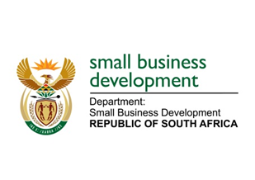
NATIONAL ASSEMBLY

QUESTION 369 FOR WRITTEN REPLY

“369. Mr M S Malatsi (DA) to ask the Minister of Small Business Development:

(a) What is the total amount that was (i) budgeted for and (ii) spent on her private office (aa) in each of the past three financial years and (bb) since 1 April 2017 and (b) what was the (i) remuneration, (ii) salary level, (iii) job title, (iv) qualification and (v) job description of each employee appointed in her private office in each of the specified periods?”
NW391E
REPLY:

The Ministerial Handbook provides guidelines on the appointment of the staff in the Private Office. It equally provides the recommended salary levels of each post. The salary levels are adjusted on an annual basis as prescribed in the Public Service Regulations.

The Office of the Minister has a staff complement as defined in the Ministerial Handbook. In line with the Protection of Personal Information Act (PoPi) and the Basic Conditions of Employment Act, I am unable to provide the members with such confidential information in the manner it is requested.

I however draw the honourable members to the Department’s Annual Report wherein the organogram of the Department provides the information required. Should it be insufficient, the Department will make the personal files of the officials available for further scrutiny by the Auditor General as prescribed by the Act.

