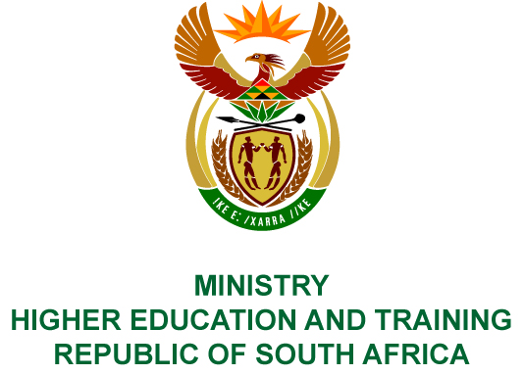
Private Bag X893, Pretoria, 0001, Tel (012) 312 5555, Fax (012) 323 5618
Private Bag X9192, Cape Town, 8000, Tel (021) 469 5150, Fax: (021) 465 7956
Memorandum from the Parliamentary Office
NATIONAL ASSEMBLY
FOR WRITTEN REPLY
QUESTION 369
DATE OF PUBLICATION OF INTERNAL QUESTION PAPER: 19/02/2016

(INTERNAL QUESTION PAPER 2 OF 2016)

Mr R W T Chance (DA) to ask the Minister of Higher Education and Training:
With reference to President Jacob G Zuma’s undertaking in his State of the Nation Address delivered on 12 February 2015, that the Government will set aside 30% of appropriate categories of state procurement for purchasing from Small, Medium and Micro-sized Enterprises (SMMEs), co-operatives, as well as township and rural enterprises, what percentage of the total procurement of (a) his department and (b) every entity reporting to him went to (i) SMMEs and (ii) co-operatives from 1 April 2015 up to the latest specified date for which information is available?
NW381E

REPLY:

- The public sector procurement system, Local Government Information System (LOGIS) and Standard Bid Documents, as utilised by the Department does not make provision to identify information on Small, Medium and Micro-sized Enterprises (SMMEs), cooperatives, township and rural enterprises. It is therefore not possible for the Department and National Skills Fund at this stage to provide the information as requested above.
- At the time of compilation, twenty of the twenty-five entities responded to the request for information.
Public Entity | - Percentage of the total procurement that went to SMMEs from 1 April 2015 to date | - Percentage of the total procurement that went to co-operatives from 1 April 2015 to date
- Agricultural Sector Education and Training Authority (AGRISETA) | 39% | 0%
- Banking SETA (BANKSETA) | 17% | 0%
- Culture, Arts, Tourism, Hospitality, Sports SETA (CATHSSETA) | 16% | 0%
- Construction Education and Training Authority (CETA) | 72% | 23%
- Chemical Industries Education and Training Authority (CHIETA) | 90% | 0%
- Council on Higher Education (CHE) | 58% | 0%
- Finance and Accounting SETA (FASSET) | 31% | 0%
- Food and Beverages Manufacturing SETA (FOODBEV) | 49% | 0%
- Health and Welfare SETA (HWSETA) | 47% | 0%
- Fibre Processing and Manufacturing SETA (FP&M) | 80% | 0%
- Insurance SETA (INSETA) | 15% | 0%
- Local Government SETA (LGSETA) | 28% | 0%
- Mining Qualifications Authority (MQA) | 98% | 0%
- National Student Financial Aid Scheme (NSFAS) | 11% | 0%
- Public SETA (PSETA) | 60% | 40%
- Quality Council for Trades and Occupations (QCTO) | 59% | 0%
- South African Qualifications Authority (SAQA) | 43% | 0%
- Services SETA | 57% | 0%
- Transport Education and Training Authority (TETA) | 70% | 0%
- Wholesale and Retail SETA (W&RSETA) | 23% | 0%

Compiler/contact persons: Messrs T Tredoux and L Kearns
Ext: 5079 and 6181

DIRECTOR – GENERAL
STATUS:
DATE:

REPLY TO QUESTION 369 APPROVED/NOT APPROVED/AMENDED

Dr BE NZIMANDE, MP
MINISTER OF HIGHER EDUCATION AND TRAINING
STATUS:
DATE:

