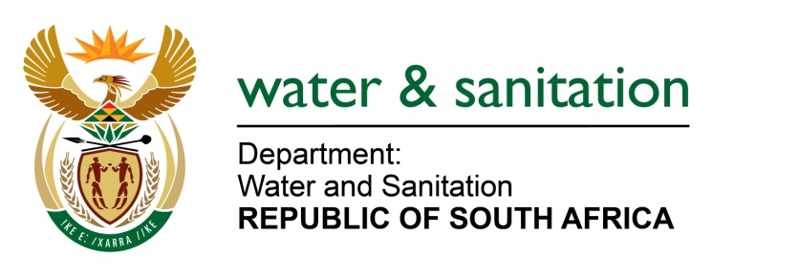

NATIONAL ASSEMBLY

FOR WRITTEN REPLY

QUESTION NO 3687

DATE OF PUBLICATION IN INTERNAL QUESTION PAPER: 14 OCTOBER 2022
(INTERNAL QUESTION PAPER NO. 38)

3687. Mrs C C S Motsepe (EFF) to ask the Minister of Water and Sanitation:
What are the reasons that the Bela-Bela community in Limpopo experiences disruptions in water supply during load shedding, often three times in a day, without any notification?
W4513E
---00O00—

MINISTER OF WATER AND SANITATION

The Bela-Bela Local Municipality has been experiencing water supply disruptions owing to the impact of load shedding by ESKOM. The water purification plant is dependent on electricity to pump water from the source to the treatment plant and from the reservoirs to the network reticulation system.

Ageing infrastructure creates also exacerbates the problem of water shortages due to regular pipe bursts which contributes to water losses and shortages in the area.

The municipality is currently implementing water restrictions as and when necessary, because of high-water demand. Availability of water depends on the reservoir levels to avoid a situation where the taps would run dry.

The Bela-Bela Local Municipality has indicated that steps are taken to notify the community timeously about water supply interruptions.

--00O00---

