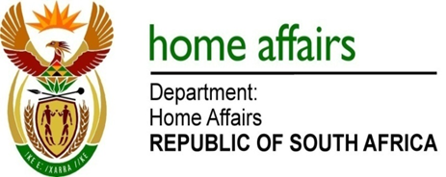

NATIONAL ASSEMBLY

QUESTION FOR WRITTEN REPLY

QUESTION NO. 3686

DATE OF PUBLICATION: Friday, 25 September 2015

INTERNAL QUESTION PAPER 39 OF 2015

3686. Ms H O Maxon (EFF) to ask the Minister of Home Affairs:

With reference to his reply to question 3272 on 18 September 2015, why (a) did his department not supply the requested information as other departments have done and (b) transactions are not recorded according to the Standard Chart of Accounts format as prescribed by the National Treasury Regulations?
NW4353E
REPLY:

- The Department uses LOGIS system for travel which does not provide field for recording purpose of trip as it is a procurement system.

- Transactions are fully recorded on LOGIS as required by Standard Chart of Accounts as prescribed by National Treasury. There is no field that caters for the purpose of the trip.

