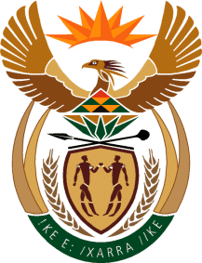

MINISTRY OF TOURISM
REPUBLIC OF SOUTH AFRICA

Private Bag X424, Pretoria, 0001, South Africa. Tel. (+27 12) 444 6780, Fax (+27 12) 444 7027
Private Bag X9154, Cape Town, 8000, South Africa. Tel. (+27 21) 469 5800, Fax: (+27 21) 465 3216

NATIONAL ASSEMBLY:

QUESTION FOR WRITTEN REPLY:
Question Number: 368
Date of Publication: 24 February 2023
NA IQP Number: 4
Date of reply:

Mr M S F de Freitas (DA) to ask the Minister of Tourism:
With reference to the proposal for sponsorship by SA Tourism (SAT) to English soccer club, Tottenham Hotspur, (a) how were the projections described at the SAT press conference on 2 February 2023 calculated and reached and (b) what are the projected time frames in this regard?
NW277E

REPLY:

I do not have any official information about this matter as yet. I have requested an official
report from SA Tourism, so that I can appraise myself about this matter.

