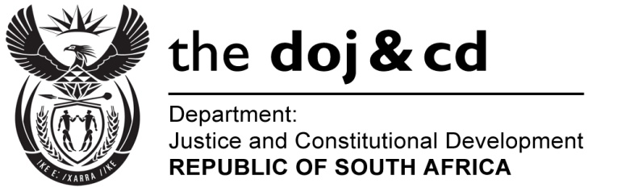

**NATIONAL ASSEMBLY**

**QUESTION FOR WRITTEN REPLY**

**PARLIAMENTARY QUESTION NO.: 3675**

**DATE OF QUESTION: 21 SEPTEMBER 2015**

**DATE OF REPLY: 16 OCTOBER 2015**

**Question:**

**Mr A R Mcloughlin (DA) to ask the Minister of Justice and Correctional Services:**

What is the (a) total amount spent and (b) breakdown of such expenditure on the compensation of each (i) commissioner, (ii) evidence leader and (iii) forensic auditor working as part of the Commission of Inquiry into allegations of fraud, corruption, impropriety or irregularity in the Strategic Defence Procurement Packages since 27 October 2012? NW4342E

**Reply:**

(a)(i) Both Commissioners are Judges from the High Court and are therefore not remunerated by the Commission.

(ii) The total cost for the evidence leaders, the research consultant and the forensic auditor from 27 October 2012 to 31 August 2015, is R73, 240 million, broken down as follows:

