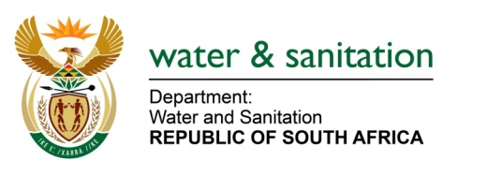

NATIONAL ASSEMBLY

FOR WRITTEN REPLY

QUESTION NO 3674

DATE OF PUBLICATION IN INTERNAL QUESTION PAPER: 10 NOVEMBER 2017
(INTERNAL QUESTION PAPER NO. 42)
3673. Mr K J Mileham (DA) to ask the Minister of Water and Sanitation:
(1) Whether all the necessary water rights have been obtained for the Hoedspruit bulk water supply pipeline currently under construction in the Mopani District Municipality in Limpopo; if not, (a) why not and (b) by which date will all the necessary water rights be obtained; if so, what are the relevant details;
(2) (a) who are the beneficiaries of the specified pipeline and (b) by which date will the pipeline deliver water for the first time to the beneficiaries? NW4105E

---00O00---
REPLY:
- The Water Use License was issued by the Department of Water and Sanitation on 30 August 2015. The issued licence authorises the Mopani District Municipality to abstract a total volume of two million, six hundred and seventy six thousand (2 676 000) cubic metres per annum of water from the Blyde River for 38 villages in the Mopani District Municipality for domestic water supply.

- Out of the 38 villages expected to benefit, the following villages are expected to benefit from Hoedspruit Bulk Water Supply:
  - Drankensburg
  - Drankenburg Park
  - Extension 10 (Retirement Village)
  - Extension 12 (Zandspruit Estate)
  - Extension 8
  - Hoedspruit Town
  - Hoedspruit Wildlife Estate
  - Extension 7 (Estimated)
  - Raptors View
  - Kampersrus
  - Scotia

The Municipality is considering amendment of the scope of work, which will now make the completed work dependent on the merged and revised scope of work, which is subject to approval. The project in question is funded through the Municipal Infrastructure Grant (MIG) and is the municipality’s project where the Department plays a supporting role but do not implement the project.

---00O00---

