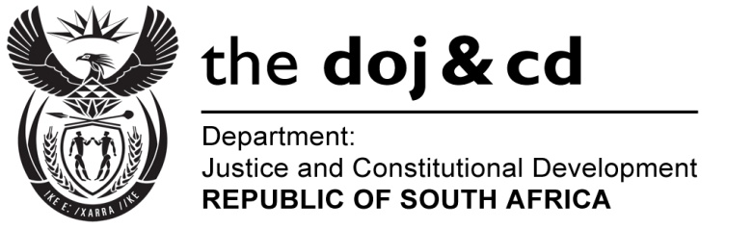

**NATIONAL ASSEMBLY**

**QUESTION FOR WRITTEN REPLY**

**PARLIAMENTARY QUESTION NO.: 3674**

**DATE OF QUESTION: 25 SEPTEMBER 2015**

**DATE OF REPLY: 12 OCTOBER 2015**

**3674. Mr A R McLoughlin (DA) to ask the Minister of Justice and Correctional Services:**

What is the (a) total amount spent and (b) breakdown of such expenditure on the Commission of Inquiry into allegations of fraud, corruption, impropriety or irregularity in the Strategic Defence Procurement Packages since 27 October 2012? NW4341E

**REPLY:**

(a) The total cost as at 31 August 2015 is R113, 232 million.

(b) The table below provides the breakdown of the expenditure up to 31 August 2015:

