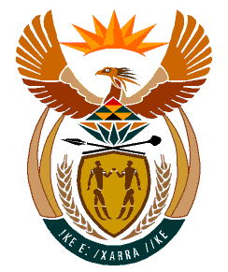

MINISTRY
HUMAN SETTLEMENTS
REPUBLIC OF SOUTH AFRICA

Private Bag X645, Pretoria, 0001. Tel: (012) 421 1309, Fax: (012) 341 8513

Private Bag X9029, Cape Town, 8000. Tel (021) 466 7603, Fax: (021) 466 3610

NATIONAL ASSEMBLY
QUESTION FOR WRITTEN REPLY
QUESTION NUMBER: PQ 3671
DATE OF PUBLICATION: 14 OCTOBER 2022

Mrs S.M. Mokgotho (EFF) to ask the Minister of Human Settlements:
On what date is it envisaged that the Reutlwile Informal Settlements at Zinniaville in Rustenberg, which was developed in 2015, will be formalised according to the request of the community?

Reply

At present, the municipality has indicated that it is not in a position to pronounce on the timeframe for the formalisation of Reutlwile Informal Settlement at Zinniaville in Rustenberg as there are a number of informal settlements in the process of being formalised, including budgetary constraints as well as the existing court order on Reutlwile Informal Settlement.

