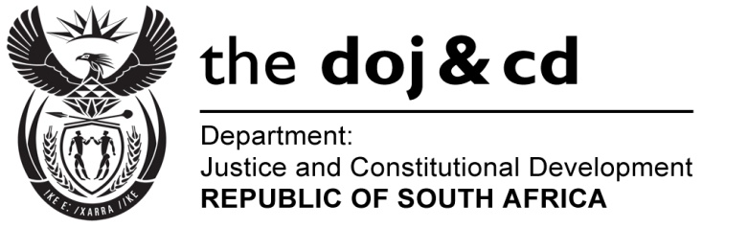

NATIONAL ASSEMBLY
QUESTION FOR WRITTEN REPLY
PARLIAMENTARY QUESTION NO.: 3662
DATE OF QUESTION: 25 SEPTEMBER 2015
DATE OF REPLY: 12 OCTOBER 2015

3662. Mr Z N Mbhele (DA) to ask the Minister of Justice and Correctional Services: [Interdepartmental transfer from Police on 25 September 2015]:

When will the recommendations of Project 107, which was initiated by the SA Law Reform Commission in 2000 relating to adult prostitution, be released? NW4329E
REPLY:

The Report will be released for public comment before the end of this year.

