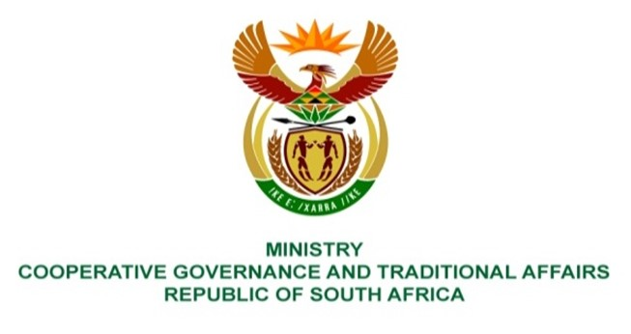
NATIONAL ASSEMBLY
WRITTEN REPLY
QUESTION NUMBER 3644
DATE OF PUBLICATION: 14 OCTOBER 2022

3644. ​Mr C Brink (DA) to ask the Minister of Cooperative Governance and Traditional Affairs:

(1)​ Whether it is permitted for traditional leaders who are remunerated, including kings, chieftains and senior traditional leaders, to simultaneously serve as remunerated public servants; if not, what is the position in this regard; if so, what are the relevant details;

(2) which specified remunerated traditional leaders are presently also appointed in remunerated positions in the Public Service? NW4462E

REPLY:

- Traditional leaders who are remunerated are not permitted to simultaneously serve as remunerated public servants.

- The Department of Traditional Affairs (DTA) does not have at its disposal, information on traditional leaders presently appointed in remunerated positions in the public service because such information is the competency of provincial departments of Cooperative Governance and Traditional Affairs.

