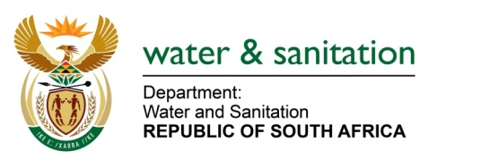

NATIONAL ASSEMBLY

FOR WRITTEN REPLY

QUESTION NO 3643

DATE OF PUBLICATION IN INTERNAL QUESTION PAPER: 10 NOVEMBER 2017
(INTERNAL QUESTION PAPER NO. 42)
3643. Ms M S Khawula (EFF) to ask the Minister of Water and Sanitation:
What is the annual water usage in each province? NW4073E
REPLY:
The Department manages water per Water Management Area (and not per ‘province’). Below is summary of the total registered volume:

WMA | Sum of Registered Volumes (cubic metres) for period: 2017-01-01 to 2017-12-31
BERG-OLIFANTS | 1 341 739 433
BREEDE-GOURITZ | 1 499 696 315
INKOMATI-USUTHU | 2 479 490 938
LIMPOPO | 2 153 656 956
MZIMVUBU-TSITSIKAMMA | 1 914 733 771
OLIFANTS | 1 900 596 161
ORANGE | 2 120 134 824
PONGOLA-UMZIMKULU | 2 694 816 103
VAAL | 4 000 022 723
Grand Total | 20 104 887 223

---00O00---

