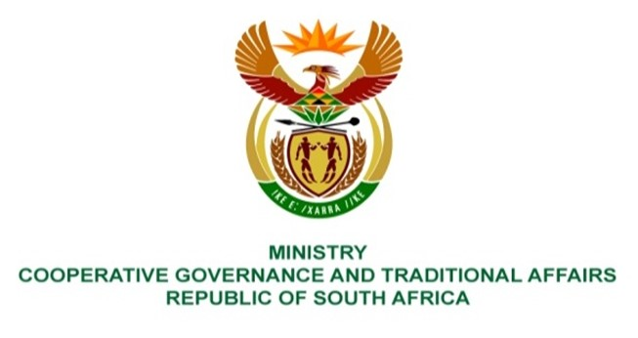

NATIONAL ASSEMBLY
QUESTION FOR WRITTEN REPLY

QUESTION NUMBER 3642
DATE OF PUBLICATION: 14 OCTOBER 2022

QUESTION:

3642. Mr C Brink (DA) to ask the Minister of Cooperative Governance and Traditional Affairs:

Whether she has ever conducted an assessment of the direct annual costs of cable theft and vandalism in municipalities; if not, why not; if so, what are the relevant details? NW4460E

REPLY:
No. Cable theft and vandalism in municipalities is criminal element which must be dealt with by South African Police Service. It is recommended that the question be redirected to the Ministry of Police to respond to the question accordingly.

