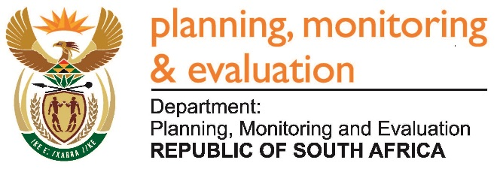 |  | 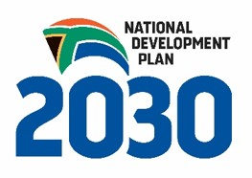
Private Bag X944, PRETORIA, 0001. Union Buildings East Wing, Government Avenue, PRETORIA
Tel: 012 312 0307. www.dpme.gov.za

364. Mr D J Stubbe (DA) to ask the Minister in The Presidency:

What is the (a) make, (b) model, (c) price and (d) date on which each vehicle was purchased for use by (i) him and (ii) his deputy (aa) in the (aaa) 2014-15 and (bbb) 2015-16 financial years and (bb) since 1 April 2016? NW417E
REPLY:
An Audi Q7 was purchased for the Deputy Minister in the 2016/17 financial year at a cost of R971, 432.76.

Approved / Not Approved

Hon. Jeff Radebe, MP
Minister in The Presidency
Date:

