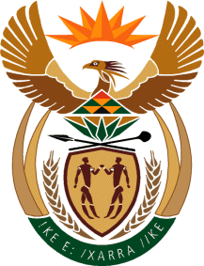

MINISTRY OF TOURISM
REPUBLIC OF SOUTH AFRICA

Private Bag X424, Pretoria, 0001, South Africa. Tel. (+27 12) 444 6780, Fax (+27 12) 444 7027
Private Bag X9154, Cape Town, 8000, South Africa. Tel. (+27 21) 469 5800, Fax: (+27 21) 465 3216

Ref: TM 2/1/1/10

NATIONAL ASSEMBLY:

QUESTION FOR WRITTEN REPLY:
Question Number: 3636
Date of Publication: 10 November 2017
NA IQP Number: 42
Date of reply: 29 November 2017

Mr T Rawula (EFF) to ask the Minister of Tourism

Whether (a) her department and/or (b) any entity reporting to her own land; if so, in each case, (i) where is each plot of land located, (ii) what is the size of each specified plot and (iii) what is each plot currently being used for? NW4065E

Reply:
- Department own land
- Where is each plot of land located | - What is the size of each specified plot | - What is each plot currently being used for
None, the Department does not own any land | Not applicable | Not applicable

- South African Tourism own land
- Where is each plot of land located | - What is the size of each specified plot | - What is each plot currently being used for
90 Protea Road, Chistlehurston; 2196 | 5345 m2 | SAT offices.

