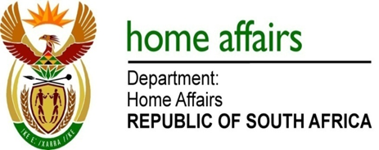

NATIONAL ASSEMBLY

QUESTION FOR WRITTEN REPLY

QUESTION NO. 3632

DATE OF PUBLICATION: Friday, 18 September 2015

INTERNAL QUESTION PAPER 38 OF 2015

3632. Mr D Bergman (DA) to ask the Minister of Home Affairs:

(1) (a) What is the total number of South African citizens who hold more than one passport who are currently residing in the country, (b) how was the specified numbers arrived at and (c) how up to date is that information;
(2) does his department have a breakdown in terms of exactly which countries the numerous second passports have been issued from; if so, which countries have issued the highest numbers of second passports to South African citizens? NW4300E
REPLY:

(1-2) The department is unable to provide the information as its obligation extends only to keeping record of the number of documents it issues to its citizens and not that of the foreign countries.

