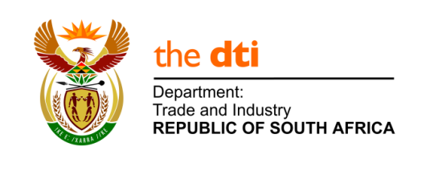

THE NATIONAL ASSEMBLY
QUESTION FOR WRITTEN REPLY
3621. Mrs E N Ntlangwini (EFF) to ask the Minister of Trade and Industry:
Whether (a) his department and/or (b) any entity reporting to him own land; if so, in each case, (i) where is each plot of land located, (ii) what is the size of each specified plot and (iii) what is each plot currently being used for?NW4050E
Response from the Department
The department does not own any land.
Response from the Entities
Entity | b | b(i) | b(ii) | b(iii)
Companies and Intellectual Property Commission (CIPC) | The CIPC does not own land | Not applicable | Not applicable | Not applicable
Companies Tribunal (CT) | The CT does not own land | Not applicable | Not applicable | Not applicable
Export Credit Insurance Corporation (ECIC) | The ECIC does not own land | Not applicable | Not applicable | Not applicable
National Consumer Commission (NCC) | The NCC does not own land | Not applicable | Not applicable | Not applicable
National Consumer Tribunal (NCT) | The NCT does not own land | Not applicable | Not applicable | Not applicable
National Credit Regulator (NCR) | The NCR does not own land | Not applicable | Not applicable | Not applicable
National Empowerment Fund (NEF) | The NEF does not own land | Not applicable | Not applicable | Not applicable
National Gambling Board (NGB) | The NGB does not own land | Not applicable | Not applicable | Not applicable
National Lotteries Commission (NLC) | The NLC does not own land | Not applicable | Not applicable | Not applicable
National Metrology Institute of South Africa (NMISA) | The NMISA does not own land | Not applicable | Not applicable | Not applicable
National Regulator For Compulsory Specifications (NRCS) | The NRCS does own land | ERF 2901 Mount Road, in the area of the Nelson Mandela Bay Metropolitan Municipality, Division of Port Elizabeth, Province of the Eastern Cape | 1,6486 hectares | The office building located on this land has been consumed by fire in 2016/17, but the NRCS is in a process to refurbish the building and use it as NRCS Regional Office in Port Elizabeth.
South African Bureau of Standards (SABS) | The SABS does own land | 1 Lategaan Street, Groenkloof, Pretoria, Gauteng  1 Apollo Road Olifantfontein 1665, Pretoria, Gauteng  20 Liesbeek Road, Rosebank, Western Cape  15 Garth Road Durban, Mayville, Kwazulu-Natal  1 Teichman Drive, Sunnyridge East London, Eastern Cape  Farm 964, Cove Road, East London, Eastern Cape  8 Bunsen Road, Secunda, Mpumalanga  22 Henrywicht Drive, Saldanha, Western Cape | 220 907 sqm  113 927 sqm  4 121 sqm  24 272 sqm  82 672 sqm  961 670 sqm  1000 sqm  647 sqm | Head office  Electrical testing facility  Regional office (Testing and Certification)  Regional Office (Certification)  Vehicle testing facility  Leased  Coal testing facility  Vacant
South African National Accreditation System (SANAS) | The SANAS does not own land | Not applicable | Not applicable | Not applicable

