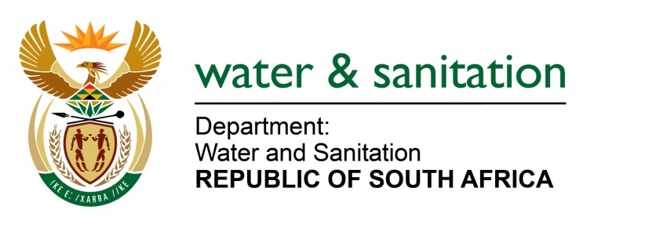

NATIONAL ASSEMBLY

FOR WRITTEN REPLY

QUESTION NO 3619

DATE OF PUBLICATION IN INTERNAL QUESTION PAPER: 14 OCTOBER 2022
(INTERNAL QUESTION PAPER NO. 38)

3619. Mrs C Phillips (DA) to ask the Minister of Water and Sanitation:
Whether, in light of the increasing demand for both potable and grey water, he will consider reintroducing the project that was shelved in 2021 which would have seen grey and potable water produced from the Acid Mine Drainage that is currently posing a threat to many buildings and homes in the eastern, central and western basins of the Witwatersrand; if not, why not; if so, what are the relevant details?
NW4436E
---00O00---

MINISTER OF WATER AND SANITATION
The Department of Water and Sanitation completed a feasibility study in 2013 for a long-term solution for Acid Mine Drainage (AMD) in the Witwatersrand as per recommendation of the 2011 Inter-Ministerial Committee (IMC) report. The long-term solution that was recommended involved further treatment of the partially treated water currently produced in the AMD treatment plants through desalination for beneficial socio-economic uses. The department commenced with preparations towards implementation of the long-term solution in 2017, but this was later put on hold due to budget constraints.
The department recognises that a significant amount of time has passed from when the feasibility study was first finalised, and for this reason is currently completing other studies to ensure the relevance of the recommendations made in 2013. This work will culminate in a revised long-term solution to be considered for implementation.
Although financial constraints remain a major challenge, the Department is also in the process to re-establish the Technology Demonstration Programme (TDP) which was also put on hold with the long-term solution in 2017. The programme is being undertaken in partnership with other stakeholders such as Water Research Commission and Department of Science and Technology and is exploring alternative technologies which can provide solutions for the AMD problem in the long-term. The TDP will be integrated with the work done by the Development Bank of South Africa through the National Water Programme.
This process will take time as proper technology selection is imperative in ensuring the most cost-effective, technologically sound, and environmentally friendly solution is implemented.
---00O00---

