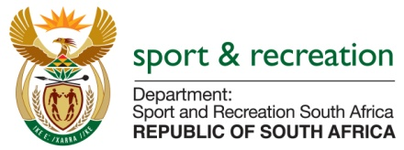

PARLIMENTARY QUESTION FOR THE MINISTER

QUESTION NO 3618
3618. Mr M S Malatsi (DA) to ask the Minister of Sport and Recreation:
Has he engaged the SA Football Association to address the inequality in match fee payments between Banyana Banyana players and Bafana Bafana players; if not, why not; if so, (a) when did the meetings take place and (b) what were the outcomes of the specified meetings? NW4286E

REPLY
The Minister has taken notice of the inequity in match fee payments amongst women's and men's national teams. The Departmental Review Committee with the Big 5 sporting bodies (Athletics, Netball, Football, Rugby and Cricket) seeks to address this matter amongst the many issues being looked into. The work includes specific support to support the National Women's teams, improvement of match fees, ring fenced funding for development and tournaments and professionalising the women's sport to attract sponsors. The situation is improving and various tailor made strategies are currently being implemented

