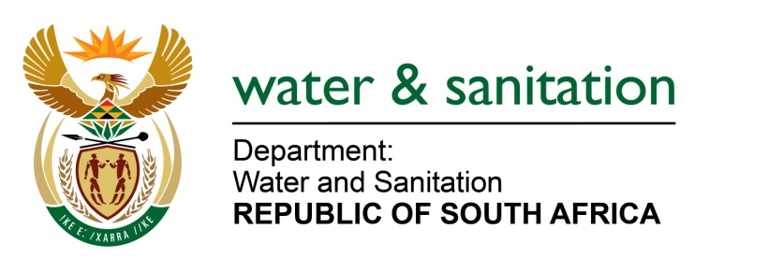

NATIONAL ASSEMBLY

FOR WRITTEN REPLY

QUESTION NO 3617

DATE OF PUBLICATION IN INTERNAL QUESTION PAPER: 14 OCTOBER 2022
(INTERNAL QUESTION PAPER NO. 38)

3617. Mrs C Phillips (DA) to ask the Minister of Water and Sanitation:
Whether he has been informed of the extended water outages experienced by many residents in Rustenburg in the North West due to load shedding at the water purification plant, the sewerage treatment plant that provides grey water to some of the platinum mines and at the pump stations pumping water to both the command and supply reservoirs; if not, what (a) is the position in this regard and (b) mitigating measures will he urgently implement to ensure that residents and businesses do not continue to be deprived of their basic human right of access to water; if so, what mitigating measures has he put in place to prevent the outages from continuing?
NW4434E
---00O00---

MINISTER OF WATER AND SANITATION

I am aware of the water supply interruptions at the Rustenburg Local Municipality (LM). An urgent notice was issued by the municipality on 27 September 2022, informing consumers of the expected water interruptions due to load shedding implemented by ESKOM. This has resulted in Water Treatment Plants not operating optimally. The municipality also reported a 40% reduction within the Magalies Water supply system, which has since recovered and is currently operating at 100%. However, the Bospoort system is still operating at 40% supply.

As a relief measure, the municipality began implementing a Water Demand Management Strategy on 14 October 2022. Based on the strategy, water supply is isolated and rotated to specific areas at a time. A schedule of water supply has been issued, detailing the supply times for different areas.

I have been advised that the municipality requested Eskom to exempt the Bospoort area from load shedding to mitigate water supply challenges and meet the current demand. However, Eskom only approved the Bospoort Water Treatment Plant to be exempted for a total of two days. The municipality has since committed to equip the Bospoort Water Treatment Plant with backup power.

I am also aware of the grey water that is supplied to the mines. The supply of treated effluent from the Rustenburg Wastewater Treatment Works to Anglo American and Impala Platinum mines was authorised in the water use authorisations for the mines as a way of promoting the wate re-use. At no point is the treated effluent pumped to any water supply reservoirs.

---00O00---

