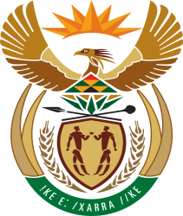

MINISTER IN THE PRESIDENCY: PLANNING, MONITORING AND EVALUATION
REPUBLIC OF SOUTH AFRICA
Private Bag X1000, Pretoria, 0001 |Tell 012 300 5200 / 021 464 2100

________________________
3613. Ms M O Mokause (EFF) to ask the Minister in The Presidency:
Whether (a) his Office and/or (b) any entity reporting to him own land; if so, in each case, (i) where is each plot of land located, (ii) what is the size of each specified plot and (iii) what is each plot currently being used for? NW4042E
Reply:
The Department of Planning, Monitoring and Evaluations (DPME) and the National Youth Development Agency (NYDA) do not own land.

