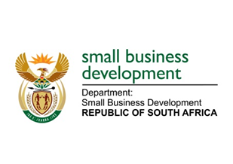
NATIONAL ASSEMBLY
QUESTION FOR WRITTEN REPLY
DUE IN PARLIAMENT: 28 OCTOBER 2022

“3607. Mr H C C Krüger (DA) to ask the Minister of Small Business Development:
(a) On what date does she intend to sign the transversal agreement with the Department of Mineral Resources and Energy concerning renewable energy and (b) what total number of (i)(aa)businesses and (bb) co-operatives will benefit from the specified programme, (ii) small, medium and micro enterprises will participate in the programme and (iii) sustainable jobs will be created in the (aa) skilled, (bb) semi-skilled (cc) unskilled job categories?”
NW4422E

REPLY: I have been advised by the department as follows:

The Department of Small Business Development (DSBD) had a series of meetings with Department of Mineral Resources and Energy (DMRE) with the view to explore areas of collaboration. The Memorandum of Understanding (MoU) between the two Departments was drafted and discussed between the two parties. It is noted that renewable energy is clearly the most substantial sector currently, and opportunities were identified for specialised SMMEs that provide the technical services and products required at different stages of development and operation. Technologies such as solar water heating, bioenergy, smart grids and smart meters provide considerable opportunities across the board for SMMEs. Beyond the various product and service sectors and value chains, another key area of intervention is to support SMMEs to make them greener, more sustainable and thereby more competitive.

The next phase of this development process is to draft an implementation phase with definitive targets or number of businesses and co-operatives to be supported as well as the type of interventions to be provided. The implementation plan will also outline projected number of jobs to be created and specific details about the job categories.

Given that the engagement with the DMRE is not yet complete, DSBD would not be able to concretely provide the number of enterprises and co-operatives who will benefit out of the collaboration nor the categories of enterprises and the possible jobs that could be created.

STELLA NDABENI-ABRAHAMS
MINISTER: SMALL BUSINESS DEVELOPMENT

