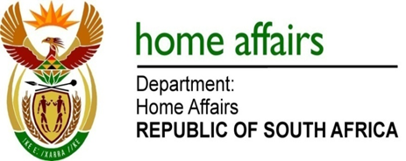

NATIONAL ASSEMBLY

QUESTION FOR WRITTEN REPLY

QUESTION NO. 3603

DATE OF PUBLICATION: FRIDAY, 10 NOVEMBER 2017

INTERNAL QUESTION PAPER 42 OF 2017

3603. Rev K R J Meshoe (ACDP) to ask the Minister of Home Affairs:

(1) (a) Whether the current electoral law is transitional or permanent; and (b) if it is transitional, by what date will it be made permanent;

(2) whether any recommendations made by the Van Zyl Slabbert Commission on Electoral Reform report of January 2003 have been implemented; if not, why not; if so, (a) which recommendations were implemented and (b) on what date were the recommendations implemented? NW4032E

REPLY:

(1) The current electoral law, namely, the Electoral Commission Act, 1996 (Act 51 of 1996), the Electoral Act, 1998 (Act 73 of 1998), and the Local Government Municipal Electoral Act, 2000 (Act 27 of 2000) are permanent and remain applicable. Section 5(1)(j) of the Electoral Commission Act empowers the Commission to continuously review legislation and to propose amendments to the national legislature. Therefore the Commission periodically makes proposals regarding amendments to electoral laws.

(2) The Electoral Task Team was established by Cabinet in 2002. The Task Team was unable to reach consensus and in consequence, two reports were presented. A majority report advocated for change in the electoral system and the minority report argued for the retention of the extant electoral system. As far as the Electoral Commission is aware, neither of the recommendations of the Majority or Minority Report of the Electoral Task Team was formally adopted and implemented. It is the prerogative of Cabinet to process the recommendations, and any consequential actions therefrom arising.

