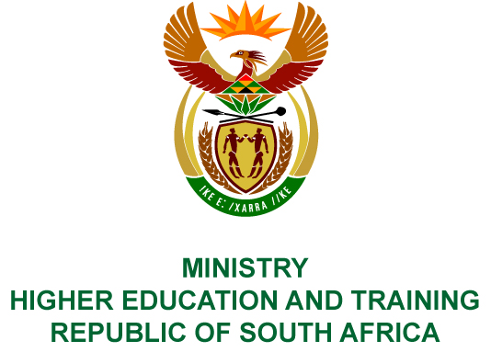
Private Bag X893, Pretoria, 0001, Tel (012) 312 5555, Fax (012) 323 5618
Private Bag X9192, Cape Town, 8000, Tel (021) 469 5150, Fax: (021) 465 7956
Memorandum from the Parliamentary Office
NATIONAL ASSEMBLY
FOR WRITTEN REPLY
QUESTION 36
DATE OF PUBLICATION OF INTERNAL QUESTION PAPER: 08/02/2018

(INTERNAL QUESTION PAPER NO 1 OF 2018)
Mr D Bergman (DA) to ask the Minister of Higher Education and Training:

(1) Whether the Culture, Arts, Tourism, Hospitality and Sport Sector Education and Training Authority (CATHSSETA) offered a certain person (name furnished) a full 4-year bursary to study International Hospitality Management (details furnished) on 30 May 2013; if so, (a) by whom and (b) on what grounds was the specified offer made;

(2) Whether the CATHSSETA subsequently withdrew the specified bursary while the specified person was overseas doing the course; if so, (a) on what date and (b) on what grounds;

(3) Whether the CATHSSETA (a) unsuccessfully defended its withdrawal of the bursary in court, forcing it to pay the bursary as originally promised and (b) subsequently pursued additional legal cases against the person; if so, what are the relevant details in each case;

(4) Whether the CATHSSETA has found that there were irregularities in the awarding of the bursary; if so, have any officials been charged with irregular conduct;
(5) What was the overall cost to CATHSSETA of the legal proceedings relating to the withdrawal of the bursary? NW41E
REPLY:
The Culture, Arts, Tourism, Hospitality and Sports Sector Education and Training Authority (CATHSSETA) has provided the following responses to the questions posed.
- Mr Lesego Luyanda Alexander was awarded a bursary to study International Hospitality Management at the Ecole Hotelliere Lausanne in Switzerland from
31 March 2013 to March 2017.
- The former Chief Executive Officer (Mr Mike Tsotetsi) approved the bursary.
- The bursary was awarded for a study field / programme on the scarce and critical skills list.
- (a) The bursary was subsequently withdrawn when CATHSSETA was placed under administration on 15 October 2015.
(b) The bursary was withdrawn as funding was not in line with the CATHSSETA funding framework and it was found to have been irregularly awarded.
- (a) Yes.
(b) CATHSSETA has filed for a counter-application to pray for a Declaratory Order to the effect that it has complied with its obligations in terms of the agreement entered into with the bursary recipient. The latter has to repay the amounts that were overpaid for the third and fourth year of his studies. The matter was set down for hearing on 29 January 2018.
- There were irregularities in the awarding of the bursary, as there were no policies regulating the process of awarding international bursaries. Furthermore, the amount awarded was not in line with the CATHSSETA bursary funding framework of R67 000.00 per learner. The relevant staff members were accordingly charged with misconduct.
- Costs still needs to be confirmed and will be made available when finalised.

COMPILER DETAILS
NAME AND SURNAME: MR MABUZA NGUBANE
CONTACT: 012 312 5896

RECOMMENDATION
It is recommended that the Minister signs Parliamentary Question 36.

MR GF QONDE
DIRECTOR–GENERAL: HIGHER EDUCATION AND TRAINING
DATE:

PARLIAMENTARY QUESTION 36 IS APPROVED / NOT APPROVED / AMENDED.
COMMENT/S

PROF HB MKHIZE, MP
MINISTER OF HIGHER EDUCATION AND TRAINING
DATE:

