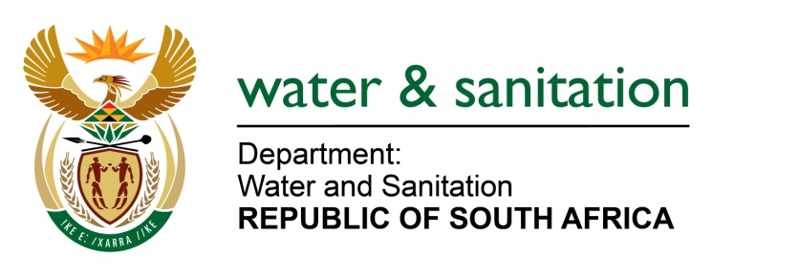

NATIONAL ASSEMBLY

FOR WRITTEN REPLY

QUESTION NO 3594

DATE OF PUBLICATION IN INTERNAL QUESTION PAPER: 3 NOVEMBER 2017
(INTERNAL QUESTION PAPER NO. 41)
3594. Mr S C Motau (DA) to ask the Minister of Water and Sanitation:
(a) What is the total number of supplier invoices that currently remain unpaid by (i) her department and (ii) each entity reporting to her for more than (aa) 30 days, (bb) 60 days, (cc) 90 days and (dd) 120 days and (b) what is the total amount outstanding in each case? NW4022E
---00O00---
REPLY:

(a)(i) My Department has currently a total of five (5) disputed unpaid invoices for more than 60 days at R 64 604.12; a total of two (2) disputed unpaid invoices for more than 90 days at R 883 101 646.14; and a total of 29 disputed unpaid invoices for more than 120 days at R 85 226 308.47.

It should be noted that there are various reasons for disputed invoices as follows:
- Discrepancies with regards to the actual invoices;
- Contractual arrangements;
- Discrepancies regarding supplier details;
- Discrepancies regarding banking details;
- Work done not supported by a certified engineer; and
- Unverifiable work.

(a)(ii) Refer to the table below for the total number of supplier invoices that are currently unpaid by my Entities:

 | Total number of supplier invoices that currently remain unpaid | Total amount outstanding in each case
(aa)Total number of supplier invoices that currently remain unpaid more than 30 days | 720 | R 116 677 218.85
(bb)Total number of supplier invoices that currently remain unpaid more than 60 days | 933 | R 47 366 803.03
(cc)Total number of supplier invoices that currently remain unpaid more than 90 days | 571 | R 170 050 648.10
(dd) Total number of supplier invoices that currently remain unpaid more than 120 days | 128 | R 125 015 841.38
TOTAL AMOUNT | 2352 | R 459 110 511.36

---00O00---

