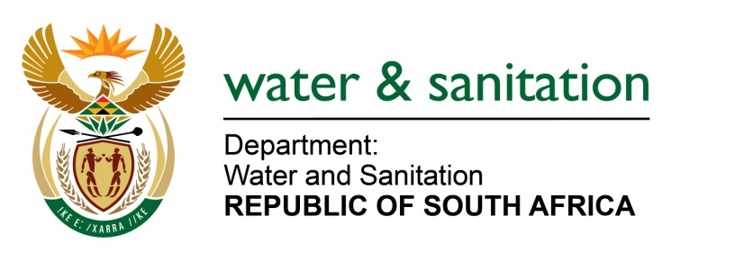

NATIONAL ASSEMBLY

FOR WRITTEN REPLY

QUESTION NO 3590

DATE OF PUBLICATION IN INTERNAL QUESTION PAPER: 18 SEPTEMBER 2015
(INTERNAL QUESTION PAPER NO. 38)
3590. Mr L J Basson (DA) to ask the Minister of Water and Sanitation:
(1) What amount will (a) her department and/or (b) the Department of Mineral Resources contribute to the (i) construction and (ii) operational costs of the proposed acid mine water desalination plants, (c) how will her department raise the specified funds for the specified plants and (d) will there be any consequences for programmes within her department which might suffer cuts; if so, what are the relevant details;
(2) whether she has any plans in place to involve the private sector in the construction and implementation of the proposed project; if not, why not in each case; if so, what are the relevant details in each case;
(3) what is the projected (a) commencement and (b) completion date of the construction of the specified plants? NW4257E
---00O00---
REPLY:
(1)(a)&(b) For the current financial year, there is no fiscal-derived funding allocated by either my Department or the Department of Mineral Resources for the construction and operation of the proposed acid mine drainage (AMD) desalination plants (long-term solution) project.

(1)(c) The Vaal River System (VRS) Reconciliation Strategy has identified AMD reclamation and beneficial use thereof as one of the key pillars for ensuring water security in the VRS. Since reclaimed AMD will augment the yield of the System and benefits all water users reliant on the VRS, it is proposed that a portion of the AMD desalination cost is recovered through the VRS Raw Water Tariff, which is levied on all water users. The balance of cost is proposed for recovery through an “environmental levy” that may be invoked in the mining sector. This dual cost-recovery mechanism ensures equity by invoking both the “user pays” and “polluter pays” principles. Any funding deficit that may result is likely to be addressed through future fiscal allocations. Having considered the foregoing funding and cost-recovery proposal, my Department was given the approval of the National Treasury to fund the AMD long-term solution project off-budget using the Lesotho Highlands Water Project (LHWP) borrowing programme (loan facility) and recover cost through the VRS Raw Water Tariff. Supplementation of the cost recovery through the proposed environmental levy is under development.
(1)(d) Irrespective of the funding model that will apply for the proposed desalination of AMD, that model will not jeopardize funding allocations to other programmes.
(2) Any potential role of the private sector in construction and/ or implementation of the proposed project will be in accordance with Government’s policy on public sector procurement for the acquisition of goods and services.

(3) It is projected that construction will commence in 2018 and would last for a minimum of 2 years. Operations are thus likely to be effective from the 2020-2021 financial year.
---00O00---

