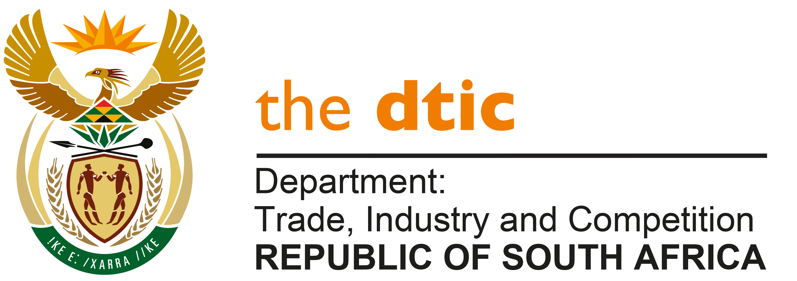

THE NATIONAL ASSEMBLY

QUESTION FOR WRITTEN REPLY

QUESTION NO. 3589

DATE PUBLISHED: 14 OCTOBER 2022

Inkosi B N Luthuli (IFP) to ask the Minister of Trade, Industry and Competition:

How does his department intend to ensure that the R300 million debt fund, known as the
SMME Crisis Partnership Fund, launched by the Gauteng provincial government, the Industrial Development Corporation and the SA SME Fund is protected against (a) corruption and (b) wasteful expenditure? NW4396E

REPLY:

I have been furnished with the information that follows, by the management of the Industrial Development Corporation (IDC):

The SMME Crisis Partnership Fund is managed by an independent Fund Manager, that being the SASME Fund.

As an investor in the fund, the Industrial Development Corporation (IDC) participates in a governance framework that has been put in place to protect the fund against corruption and wasteful expenditure. This consists of:

• Advisory Board
• Investment Committee
• IDC Oversight
• Reporting and Audit

Advisory Board

The Advisory Board is comprised of members appointed by the Investors. These members are independent in that they are not employees of the Fund Manager. The Advisory Board ensures that the Fund’s Guidelines, Policies and Procedures are adhered to. The Fund Manager may raise reasonable objections to the appointment of a prospective candidate e.g., reputational, or legal (criminal/fraud). The rights and responsibilities of the Advisory Board are to:

- approve any variations or waivers to the Fund Guidelines.
- approve increases to prudential limits on investments where specifically allowed in the Fund’s guidelines.
- advise on any governance issues that may arise in the Fund.
- review all expenses of the Fund.
- approve the appointment/replacement of the Fund’s Auditor.
- review bank statements of the Fund.
- review the annual valuations of investments, and to the extent that there is any dispute in respect of a valuation refer the issue to a recognised expert for final determination.
- to resolve any material conflict of interest between the Fund Manager and the Investors or the investors themselves arising from a Fund transaction.

Investment Committee
The Investment Committees key role is to:
- Approve or decline investments or exits from investments.
- Monitor and report to Investors the performance of the investments.
- Approve third party expenses to be borne by the Investors in respect of investments or exits.
- Ensure that the Fund manager implements the Investment Policy of the Fund as negotiated with Investors.

The committee is established and hosted by the Fund Manager. The Investment Committee members are individuals independent from the Fund Manager who possess the requisite industry, technical and financial skills to make investment decisions in accordance with the investment mandate and terms of the Fund.

IDC Oversight
IDC ensure appropriate oversight of the fund through representation on the Advisory Board and the Investment Committee. IDC has appointed senior staff who possess the requisite experience in respect of deal assessment, development finance and township sector knowledge to sit on these committees.

In addition, the IDC has a senior person responsible for constant oversight of the Fund and the Fund Manager.

Payments to the fund by the IDC are made as the fund invests in the SMMEs and not in a single lump sum. To effect disbursement of monies to the Fund, the Fund Manager must provide to the IDC the minutes of the Fund’s IC meetings showing which applicants have been approved for investment and the value of the investment.

Reporting and Audit

The fund manager is required to:

- Provide monthly reports to IDC on the performance of the Fund within 7 days after each month-end. The report will cover but not be limited to relevant fund performance indicators including approvals, cancellations disbursements, impairments, distressed investees, realised and projected financial returns and latest valuation of the Fund (and each of its underlying investments); number of jobs created/ saved, the number and value of investments to black owned investees.
- provide management accounts of the Fund and the Fund Manager to IDC on a quarterly basis within 30 days after each quarter-end.
- provide the IDC with audited annual financial statements of the Fund and Fund Manager within 6 months after its year-end.

-END-

