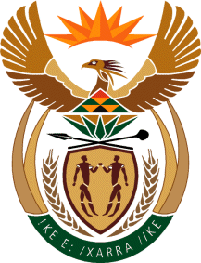
MINISTRY
SPORT AND RECREATION
REPUBLIC OF SOUTH AFRICA

Department of Sport and Recreation l Private Bag X896 l PRETORIA l 0001 l Regent Place l 66 Queen Street l Pretoria l 0001 l +27 (0)12 304 5158 l Fax: +27 (0)12 323 8426
Private Bag X9149 l Cape Town l 8000 l 2nd Floor Parliament Building l 120 Plain Street l CAPE TOWN l Tel: +27 21 469 5705 l Fax: +27 21 465 4402
www.srsa.gov.za
_____________________________________________________________________

NATIONAL ASSEMBLY

WRITTEN REPLY

QUESTION PAPER: No. 41 of 03 NOVEMBER 2017

DATE OF REPLY: 01 DECEMBER 2017

3588. Ms T M Mbabama (DA) asked the Minister of Sport and Recreation:
(a) What is the total number of supplier invoices that currently remain unpaid by (i) his department and (ii) each entity reporting to him for more than (aa) 30 days, (bb) 60 days, (cc) 90 days and (dd) 120 days and (b) what is the total amount outstanding in each case? NW4016E
______________________________________________________________________

The Minister of Sport and Recreation

REPLY:

(a) (i) and (ii) (aa), (bb) (cc) and (dd) There are no invoices remaining unpaid in the categories stipulated by the Honourable Member.

*********************************

