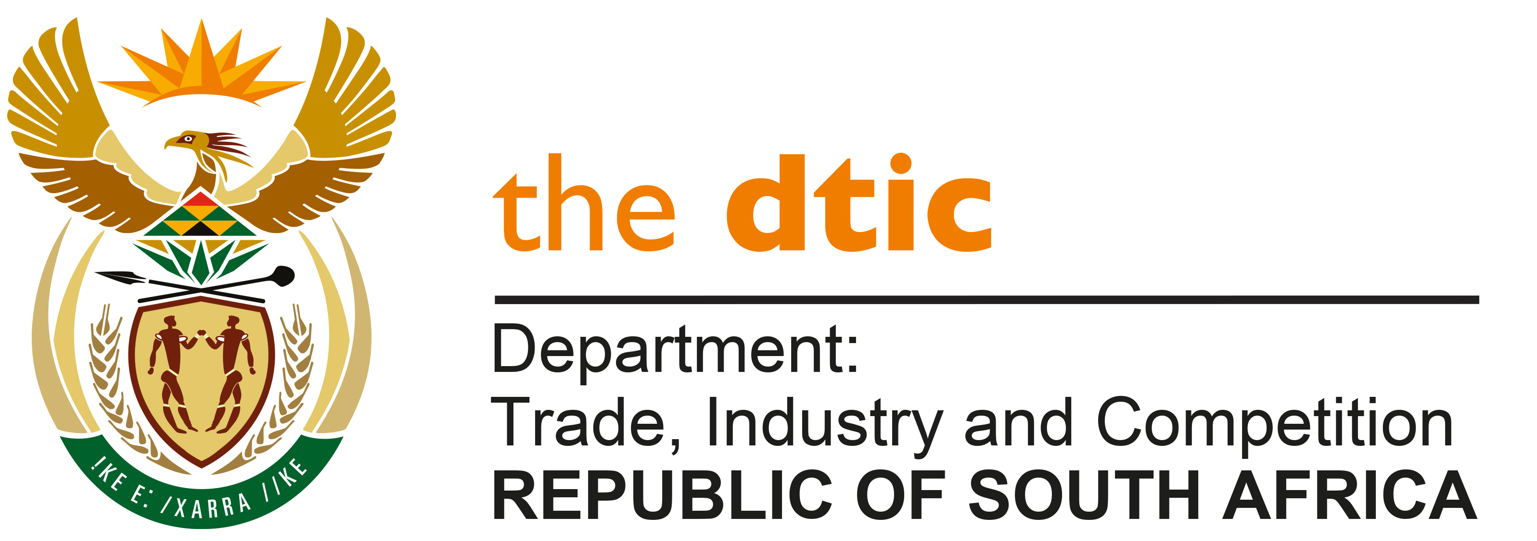

THE NATIONAL ASSEMBLY

QUESTION FOR WRITTEN REPLY

QUESTION NO. 3587

DATE PUBLISHED: 14 OCTOBER 2022

Inkosi B N Luthuli (IFP) to ask the Minister of Trade, Industry and Competition:

Whether any trade agreements were signed and/or agreed to at the 9th session of the South Africa-Saudi Arabia Joint Economic Commission; if not, why not; if so, what are the relevant details? NW4394E

REPLY:

No trade agreements were signed at the recent South Africa-Saudi Arabia Joint Economic Commission (JEC) meeting held in Pretoria on 3-4 October 2022.

The JEC was convened inter alia in order to prepare the work for the planned State Visit to Saudi Arabia subsequently undertaken by President Ramaphosa on 15-16 October 2022, at which several economic cooperation agreements were signed. The JEC was therefore a useful clearing-house and opportunity to identify the status of negotiations on such proposed agreements.

-END-

