NATIONAL ASSEMBLY
36/1/4/1(201900037)

FOR WRITTEN REPLY QUESTION 358
DATE OF PUBLICATION IN INTERNAL QUESTION PAPER: 22 FEBRUARY 2019 (INTERNAL QUESTION PAPER NO 3-2019)

358. Mr M Waters (DA) to ask the Minister of Police:

- With reference to his reply to question 3778 on 15 January 2019, (a) what is the name of the police officer commonly called Gold Tooth, (b) where is he currently stationed and (c) what promotions has he received since the Carte Blanch exposé;

- what (a) specific action was taken against Constable Mapatlare and (b) is his responsibilities at the Ekurhuleni North Cluster offices?

REPLY:
NW382E

(1)(a) The name of the police officer is Constable DM Mapatlare.

(1)(b) The member is stationed at the Ekurhuleni North Cluster.

(1)(c) The member did not receive any promotion, since the Carte Blanche exposé.

(2)(a) A departmental case was investigated against the member and he was suspended without salary, privileges and benefits. The member was reinstated after the complainant relocated to the United Kingdom and failed to testify at the departmental trial. The criminal case, Edenvale, CAS 311/05/2015, was withdrawn at the court, due to the same reason.

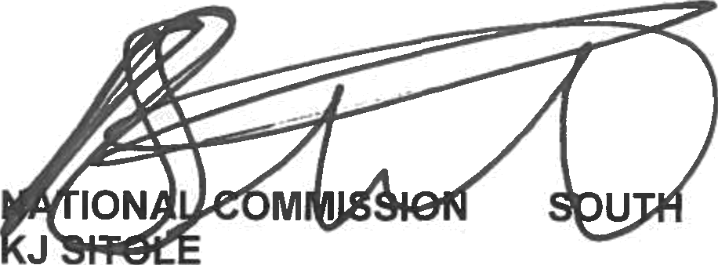
(2)(b) The member performs duties as a crime prevention official. Reply to question 358 recommended/

(SOEG)

ER:
GENERAL AFRICAN POLICE SERVICE

3

Reply to question 358 approved/not approved

MINISTER OF POLICE BH CELE, MP

Date:

