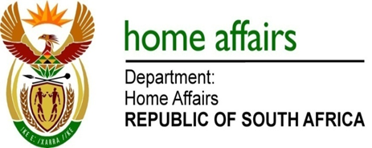

NATIONAL ASSEMBLY

QUESTION FOR WRITTEN REPLY

QUESTION NO. 358

DATE OF PUBLICATION: Friday, 3 March 2017

INTERNAL QUESTION PAPER 7 OF 2017

358. Mr B R Topham (DA) to ask the Minister of Home Affairs:

What is the (a) make, (b) model, (c) price and (d) date on which each vehicle was purchased for use by (i) him and (ii) his deputy (aa) in the (aaa) 2014-15 and (bbb) 2015-16 financial years and (bb) since 1 April 2016? NW411E

REPLY:

During the 2014-15 financial year, a BMW 535i sedan was procured for the use of the Minister. The vehicle was procured on 30 January 2015 for the purchase price of R750 122.76. No other vehicles were procured for the Minister or his deputy subsequent to 30 January 2015.

:

