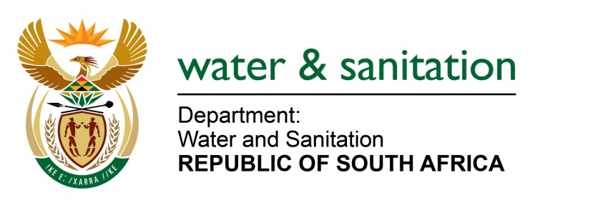

NATIONAL ASSEMBLY

FOR WRITTEN REPLY

QUESTION NO 3577

DATE OF PUBLICATION IN INTERNAL QUESTION PAPER: 14 OCTOBER 2022
(INTERNAL QUESTION PAPER NO. 38)

3577. Ms S A Buthelezi (IFP) to ask the Minister of Water and Sanitation:

(1) Given that parts of the Republic are experiencing water shedding at present, what significant progress has been made in the water sector under Operation Vulindlela in relation to the water shortages in certain parts of the Republic;

(2) (a) how has his department contributed to modernising and transforming the outdated bulk water infrastructure of the Republic and (b) what proactive measures are in place to prevent water shedding from becoming a semi-permanent fixture similar to load shedding in South African households?

NW4383E
---00O00---

MINISTER OF WATER AND SANITATION
- The main purpose of the Operation Vulindlela is to accelerate the implementation of structural reforms and support economic recovery, as such the Department of Water and Sanitation (DWS) is implementing following projects under Operation Vulindela:

- Revival of the Green Drop, Blue Drop and No Drop Assessment Programme: The asessment programmes are aimed at improving the wastewater quality, water supply quality and water use efficiency in all the 144 Water Service Authorities. The Department published the Green Drop report in March 2022 and will publish the Blue and No Drop programme in next financial year.
- Improvement of Water Use Authorisation: The Department is revising the water use authorisation process with the intention being able to process all water use applications within 90 days to ensure economic development and access to water.

- Independent Economic Regulator: The Minister has appointed the Regulator Commission for the period of 3 years. The aim of an independent economic regulator to regulate tariffs, standards, and performance in the water services sector.

- (a)The department is funding refurbishment of infrastructure through its Water Services Infrastructure Grant (WSIG) programme. Regional Bulk Infrastructure Grant (RBIG) facilitates achievement of targets for access to bulk water and sanitation through successful execution and implementation of bulk projects of regional significance. The main purpose of this grant amongst others is to:

- To develop new, refurbish, upgrade and replace ageing bulk water and sanitation infrastructure of regional significance that connects water resources to infrastructure serving extensive areas across municipal boundaries or large regional bulk infrastructure serving numerous communities over a large area within a municipality

- To implement bulk infrastructure with a potential of addressing Water Conservation and Water Demand Management (WC/WDM) projects or facilitate and contribute to the implementation of local WC/WDM projects that will directly impact on bulk infrastructure requirements. This is achieved through project planning, where diversification of water resources is encouraged as part of calculating the Water Balance to ensure sustainability of supply
(b)The Department undertakes planning studies over different planning horizons, to derive interventions that are implemented to ensure water security for the entire country. These interventions cover the enablers like governance, financing, human capacity building and science and innovation which facilitate implementation of water projects at National, Provincial and District and Local Municipality level. The interventions implemented for our water security are contained in the National Water Resource Strategy (NWRS), the instrument by which the Minister gives effect to the National Water Act, as well as the master plans that emanate from the NWRS. The various studies informing the NWRS are available on the DWS website, at http://www6.dwa.gov.za/iwrp/projects.aspx and the National Water and Sanitation Master Plan (NW&SMP) is available at http://www.dwa.gov.za
The DWS also monitors the capacity of municipalities to deliver water and sanitation through the Municipal Strategic Self-Assessment (MuSSA); a web-based system that enables municipalities to conduct their self-assessment on critical aspects service delivery performance. The outcomes of the assessment position the Department and other sector role players to provide targeted support to local government through various support and intervention programmes aimed at improving services delivery, governance and business health. Priority areas are identified and addressed through the development of a Municipal Priority Action Plan (MPAP).

Lastly, Five-Year Reliability Water and Sanitation Plans will soon be rolled out in all forty-four (44) District Municipalities. The plans are meant to:
- Ensure sustainable and reliable water services with the service-standard yardstick that has a 100% compliance to functionality, water security and effective governance to maintain appropriate levels of service delivery
- Conduct primary situational assessments of the water services and infrastructure supply conditions and classify each situation into a reliability category. The solution options are then integrated to proposed projects, specifically integrating all funding programmes to alleviate new infrastructure needs and achieve reliability of water services.
Recently the Department has developed the Water Services Improvement Programme (WSIP). The aim of WSIP is to guide Department in initiating and leading the national support and regulatory interventions to reverse the decline in the provision of water and sanitation services in all municipalities. The programme consists of the following four key elements:
- In terms of the Water Services Act, DWS will issue updated and more comprehensive norms and standards for water and sanitation services.
- DWS will publish a National Regulatory Dashboard showing the extent of compliance with national norms and standards for water services for all Water Service Authorities, drawing on existing monitoring information, including from the Drop reports, NT, and COGTA reports (no new additional reporting requirements will be put on municipalities).
- DWS will develop rolling regional support and intervention plans based on the evidence in the Regulatory Dashboard, managed by its regional offices, in consultation with provincial governments, municipalities and DDM structures.
- The support and intervention plans will draw on a range of support programmes which will be developed at national level.

---00O00---

