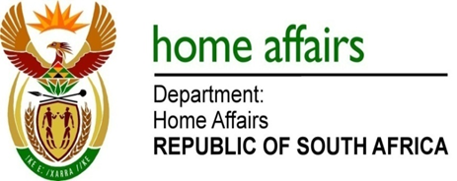

NATIONAL ASSEMBLY

QUESTION FOR WRITTEN REPLY

QUESTION NO. 3573

DATE OF PUBLICATION: FRIDAY, 3 NOVEMBER 2017

INTERNAL QUESTION PAPER 41OF 2017

3573. Dr A Lotriet (DA) to ask the Minister of Home Affairs:

(a) What is the total number of supplier invoices that currently remain unpaid by (i) her department and (ii) each entity reporting to her for more than (aa) 30 days, (bb) 60 days, (cc) 90 days and (dd) 120 days and (b) what is the total amount outstanding in each case? NW4001E
REPLY:

The information received from the Department and the entities are tabulated as follows:

- Department of Home Affairs

- (i) | - Number of supplier invoices | - Total amount outstanding
(aa) more than 30 days | 27 | 1 226 438.62
(bb) more than 60 days | 7 | 160 512.14
(cc) more than 90 days | 1 | 1 240.31
(dd) more than 120 days | 3 | 4 898.52
GRAND TOTAL | 32 | 1 393 089.59

- Government Printing Works

- (i) | - Number of supplier invoices | - Total amount outstanding
(aa) more than 30 days | 1 | 15 352.02
(bb) more than 60 days | 2 | 59 022.36
(cc) more than 90 days | 0 | 0
(dd) more than 120 days | 3 | 44 114.30
GRAND TOTAL | 6 | - 488.68
- Electoral Commission

- (i) | - Number of supplier invoices | - Total amount outstanding
(aa) more than 30 days | 11 | 119 422.00
(bb) more than 60 days | 2 | 2 156.00
(cc) more than 90 days | 0 | 0
(dd) more than 120 days | 19 | 32 818.00
GRAND TOTAL | 32 | 154 396.00

