NATIONAL ASSEMBLY

WRITTEN REPLY

PARLIAMENTARY QUESTION 3567

DATE OF PUBLICATION: 3 November 2017
Ms SP Kopane (EFF) to ask the Minister of Economic Development:
(a) What is the total number of supplier invoices that currently remain unpaid by (i) his department and (ii) each entity reporting to him for more than (aa) 30 days, (bb) 60 days, (cc) 90 days and (dd) 120 days and
(b) what is the total amount outstanding in each case? NW3995E

REPLY
- The Economic Development Department, IDC, ITAC and Competition Tribunal EDD do not have any outstanding supplier invoices that remain unpaid for more than 30 days.

- The Competition Commission currently has 40 outstanding invoices.
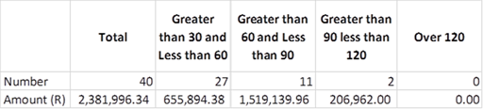

The reasons are as follows:
Banking Details outstanding: 13
Unresolved dispute with the supplier: 9
Supply Chain Documents outstanding: 18

The Competition Commission is still in discussion with the suppliers to have all payments resolved.

-END-

