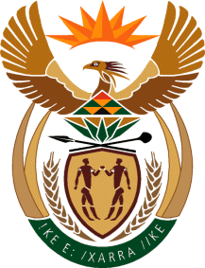

MINISTRY OF TOURISM
REPUBLIC OF SOUTH AFRICA

Private Bag X424, Pretoria, 0001, South Africa. Tel. (+27 12) 444 6780, Fax (+27 12) 444 7027
Private Bag X9154, Cape Town, 8000, South Africa. Tel. (+27 21) 469 5800, Fax: (+27 21) 465 3216

NATIONAL ASSEMBLY:

QUESTION FOR WRITTEN REPLY:
Question Number: 356
Date of Publication: 17 February 2023
NA IQP Number: 2
Date of reply: 27 February 2023

Mr A Matumba (EFF) to ask the Minister of Tourism:

What (a) total number of resorts (i) does her department own in the Republic and (ii) are functional and in good state and (b) steps has her department taken to revive the dysfunctional state-owned resorts? NW371E

REPLY:

(a) (i) The department owns none [Zero (0)] of the state-owned resorts.
(ii) Information on the functionality of such resorts may be obtained from the respective owning
entities (i.e. Provincial, some National Entities like SANParks and Municipalities)

(b) (i)-(iii)
The Department assisted with maintenance of some of the National and Provisional state
owned tourism facilities. The Department has also developed a budget resort Network and
Brand Concept for piloting.

