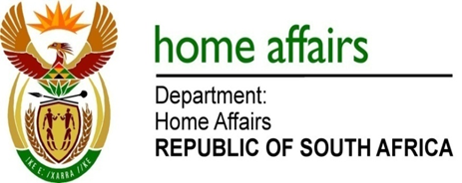

NATIONAL ASSEMBLY

QUESTION FOR WRITTEN REPLY

QUESTION NO. 356

DATE OF PUBLICATION: FRIDAY, 16 FEBRUARY 2018

INTERNAL QUESTION PAPER 2 OF 2018

356. Ms C King (DA) to ask the Minister of Home Affairs:

(a) What is the total amount that was (i) budgeted for and (ii) spent on her private office (aa) in each of the past three financial years and (bb) since 1 April 2017 and (b) what was the (i) remuneration, (ii) salary level, (iii) job title, (iv) qualification and (v) job description of each employee appointed in her private office in each of the specified periods? NW378E
REPLY:

As the parliamentary question was directed to the former Minister of Home Affairs, Ms Ayanda Dlodlo, MP at the time, this response addresses the budget and personnel within Minister Dlodlo’s office during her tenure within the Department of Home Affairs only which commenced on 17 October 2017 until 26 February 2018.

- The information is as follows in the table below:

Financial years | - Budget | - Expenditure
 | R’000 | R’000
1 April 2015 – 31 March 2016 | 22 043 | 21 792
1 April 2016 – 31 March 2017 | 27 788 | 25 451
1 April 2017 – 23 February 2018 | 24 103 | 14 091
Total | 73 934 | 61 334

- The information requested at (b) (i) – (v), is herewith attached as Annexure A.

