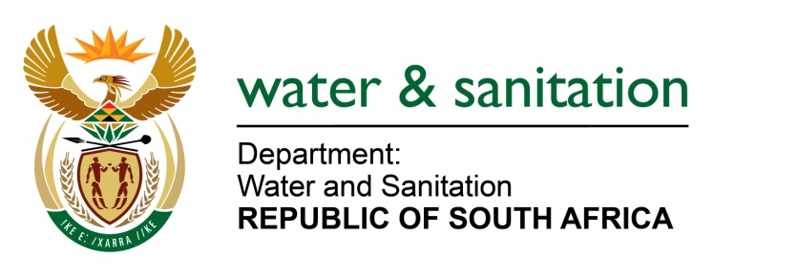

NATIONAL ASSEMBLY

FOR WRITTEN REPLY

QUESTION NO 3556

DATE OF PUBLICATION IN INTERNAL QUESTION PAPER: 14 OCTOBER 2022
(INTERNAL QUESTION PAPER NO. 38)

3556. Mr P Mey (FF Plus) to ask the Minister of Water and Sanitation:

(1) Whether his department has been informed that the residents of Ward 59, Ogunjini, Verulam in the eThekwini Metropolitan Municipality in KwaZulu-Natal, have been without water supply for a number of years and that the water supplied by water tankers is insufficient to meet the requirements of the households of the specified community; if not, why not; if so, what measures is his department taking to intervene in the matter.

(2) what is the average cost (a) per tanker to supply the community with water and (b) to sink boreholes to supply sufficient fresh water to the community.

(3) whether his department would consider sinking boreholes to address the community’s water crises, should it prove to be cost beneficial; if not, why not; if so, what are the relevant details.

(4) whether he will make a statement on the matter?

NW4362E
---00O00---

MINISTER OF WATER AND SANITATION
- The residents of Ogunjini in Ward 59 of eThekwini Metro have been receiving water supply from a 1Ml/day Ogunjini water treatment works. A project implemented by the eThekwini Metro to upgrade the treatment plant to 2Ml/day is planned for completion by September 2023.

Eight 16 000 litre water tankers with a minimum of two loads per day, have been permanently deployed to the area by the eThekwini Metro. It is expected that this current deployment plan will remain in force until the completion of the treatment works upgrade.

(2) a) The current average cost per tanker to supply the community with water is estimated at R4 000 per day.

b) The cost to sink a borehole is estimated at R331,000 per borehole at varying capacity outputs to be determined upon testing.

(3) The municipality is currently implementing an emergency borehole rehabilitation and installation programme while a full roll-out of the programme is at tender stage. The Ogunjini areas have also been considered for this programme.

(4) The Department of Water and Sanitation will continue to monitor the water services supplied to the area by the Ethekwini Metro and provide support if required.
---00O00---

