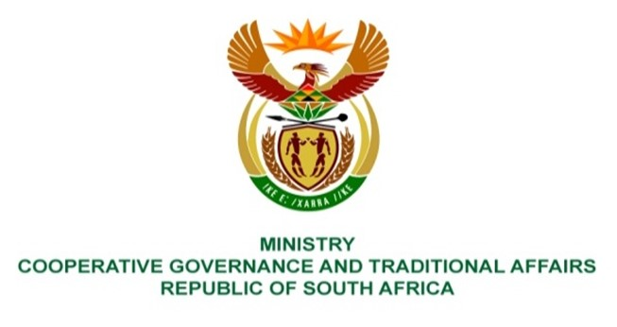

NATIONAL ASSEMBLY
QUESTIONS FOR WRITTEN REPLY

QUESTION NUMBER 3554
DATE OF PUBLICATION: 14 OCTOBER 2022

QUESTION:

3554. Mr I M Groenewald (FF Plus) to ask the Minister of Cooperative Governance and Traditional Affairs:

(1) Whether, with reference to her reply to question 1083 on 8 April 2022, any steps were taken by her department to ensure that the 203 municipalities that did not have any infrastructure maintenance plans in place, will develop and implement such plans as a matter of priority; if not, why not; if so, what steps;

(2) what total number of the 18 municipalities that only partially implemented their infrastructure maintenance plans have now fully implemented their plans;
(3) whether she will make a statement on the matter?
Responses:

- Yes, as at 1 July 2022, all Municipal Infrastructure Grant (MIG) receiving municipalities were allowed and encouraged to utilise up to 5 per cent of their respective MIG allocations to fund activities related to the development of an Infrastructure Asset Management Plan (IAMP). Furthermore, municipalities that have non-compliance pre-directives or directives with the Department of Water and Sanitation (DWS) may spend up to 10 per cent of their allocations for the urgent repair and refurbishment of water and sanitation infrastructure to restore functionality. These MIG conditions were included in the Division of Revenue Bill (DORA) published in the Government Gazette No. 45903 of 11 February 2022. These reforms were implemented in an effort to ensure that municipalities do not only focus on capitalization, but also set aside funding and invest in maintenance (asset care) of infrastructure.

The Department of Corporate Governance (DCOG) through the Municipal Infrastructure Support Agent (MISA) continues to deploy professionally registered built environment practitioners (Civil and Electrical Engineers as well as Town and Regional Planners) to municipalities to provide technical support and advice on developing and implementing infrastructure maintenance plans. To date MISA, has deployed 73 professionally registered built environment practitioners to support municipalities in accordance with the District Development Model (DDM).

- None of the 18 municipalities are reported to have fully implemented their infrastructure maintenance plans. The progress will be measured at the end of this financial year (2022/23) as the MIG reforms focusing on Asset Management, Repairs and Maintenance commenced on 1 July 2022. However, it is worth noting that there is paradigm shift towards prioritizing asset care and activities of repairs and maintenance of infrastructure by municipalities as assessed from the business plans being received for project prioritisation.

- No.

