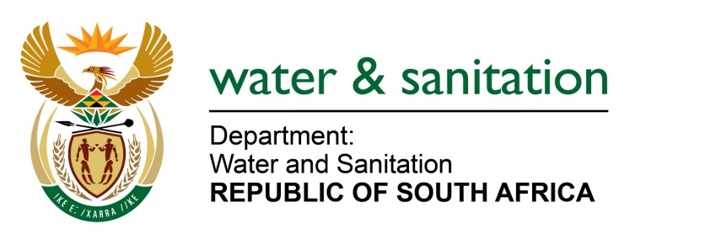

NATIONAL ASSEMBLY

FOR WRITTEN REPLY

QUESTION NO 3549

DATE OF PUBLICATION IN INTERNAL QUESTION PAPER: 14 OCTOBER 2022
(INTERNAL QUESTION PAPER NO. 38)

3549. Mrs M O Clarke (DA) to ask the Minister of Water and Sanitation:

(1) Whether, with reference to the report on Gravelotte Mines Geotechnical Concerns Pertaining to Flooding in April 2022, his department has been advised that ingress water is decanting anywhere else other than where the Trans-Caledon Tunnel Authority (TCTA) and his department are aware of; if not, what is the position in this regard; if so,

(2) whether the ingress water has been tested; if not, why not; if so, what quantity of water is being treated by TCTA;

(3) whether any water is prevented from coming in due to the pump failure; if not, what is the position in this regard; if so, what steps is TCTA taking in this regard at the moment;

(4) what (a) are the reasons that the information has not been made available, (b) are the interim plans for mitigation while the pumps cannot be made functional soon enough, (c) is the level of the water at the moment and (d) are the financial costs involved?

NW4301E
---00O00---

MINISTER OF WATER AND SANITATION
- There have been no reports to the Department of Water and Sanitation that there are currently any decants elsewhere. There are also no decants at the Eastern Basin plant where the TCTA is abstracting and pumping from.

The water level in the void is monitored daily and was 43.06 metres below ground level as of 17 October 2022. The DWS has scheduled a site visit on 25 October 2022 to Gravelotte Mines to assess the situation

It should be noted that each mine is responsible for pumping and treating water within its own mining area and ensuring the safety of its personnel and the environment it holds a mining right for.

- Mine impacted water / acid mine drainage water in the void is tested daily when the plant is operating, and groundwater tests are conducted quarterly through the use of boreholes. Due to the plant being offline, the frequency of ground water testing has been increased from quarterly to monthly.

Depending on the results, the frequency may be increased to ensure the DWS and TCTA monitors possible ground water contamination closely. As the Eastern Basin AMD Treatment plant is offline, no water is currently being treated.

- Ingress control measures are the mandate of DMRE and as such, DMRE would be in a better position to provide more clarity regarding the projects it is currently working on to reduce the total amount of water flowing into the Witwatersrand voids.

- (a) The information is made available to the various forums on a regular basis and the Department and TCTA further responds to all stakeholder queries as and when needed.

(b)TCTA in partnership with Gold-One has procured 3 new motors in July 2022 and the factory acceptance tests for the new motors were conducted successfully on 29 September 2022 in China. The motors will be shipped to RSA on 21 October 2022.

A service provider is busy servicing the pump and will also make the modifications to the pump to be compatible with the new motor from China. It is expected that the plant will be operational early December 2022.

(c) The level at the Eastern Basin AMD Treatment plant was 43.06 metres below surface as of 17 October 2022.

(d) The cost of operations and maintenance in the Eastern Basin for the financial year 2021-2022 was R72 million while the cost of repairing the motors to date is R15.5 million.
---00O00---

