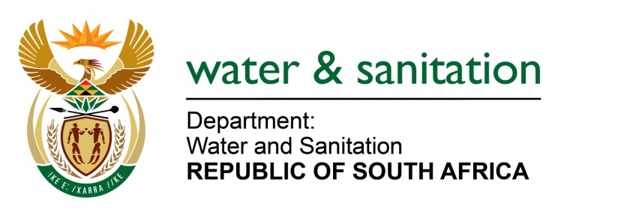

NATIONAL ASSEMBLY

FOR WRITTEN REPLY

QUESTION NO 354

DATE OF PUBLICATION IN INTERNAL QUESTION PAPER:
(INTERNAL QUESTION PAPER NO. 2) 17 FEBRUARY 2023

354. Mrs M R Mohlala (EFF) to ask the Minister of Water and Sanitation:
(1) What are the findings of his department in respect of its engagement with stakeholders on the draft National Water Resources Infrastructure Agency Bill;
(2) whether the National Economic Development and Labour Council has been consulted regarding the specified Bill; if not, why not; if so, what are the relevant details? NW369E
---00O00---

MINISTER OF WATER AND SANITATION

- The Minister of Water and Sanitation published the National Water Resource Infrastructure Agency Bill on 16 September 2022 in Government Gazette notice: 46917 p137, for a period of 90 days which concluded on 16 December 2022. During the 90-day period, the Department of Water and Sanitation (DWS) embarked on an extensive consultation process to solicit comments on the Bill from its various stakeholders. The comments received to date have been found favourable and supportive towards the establishment of the National Water Resource Infrastructure Agency, as an institution proposed in the Bill.

The period for consultation has been formally extended in government gazette notice: 48017 p43 published 10 February 2023, which period will conclude on 17 March 2023. The reason for the extension of the consultation period to is to ensure a comprehensive all-inclusive consultation process, by providing the primary creditors of the Trans- Caledon Tunnel Authority (TCTA) with an independent legal and financial opinion on the terms of the loans agreements currently entered with the TCTA in relation to the provisions of the Bill and also to allow for the National Economic Development and Labour Council (NEDLAC’s) Development chamber to appoint a task team that will be considering the Bill.

- Yes, the National Economic Development and Labour Council’s Development Chamber was consulted on 12 December 2022. The NEDLAC’s Development chamber is expected to appoint a task team to further consider the Bill.

