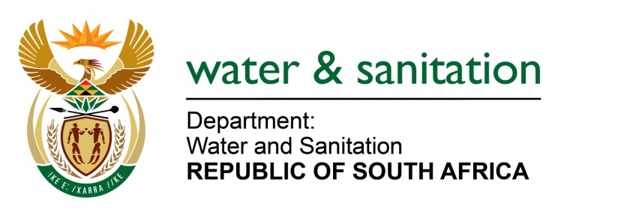

NATIONAL ASSEMBLY

FOR WRITTEN REPLY

QUESTION NO 3538

DATE OF PUBLICATION IN INTERNAL QUESTION PAPER: 18 SEPTEMBER 2015
(INTERNAL QUESTION PAPER NO. 38)
3538. Ms M S Khawula (EFF) to ask the Minister of Water and Sanitation:
Whether any parts of Botshabelo Section K and Mangaung still use the bucket system; if so, (a) how many and (b) when is her department planning to completely eradicate the use of the bucket system in the specified areas? NW4202E
---00O00---
REPLY:
- Botshabelo has a total of 757 Buckets of which 155 are located in Section K. Buckets are scattered throughout the settlement and mostly on informal stands. Mangaung Metropolitan Municipality has a total of 1 347 Bucket toilets to be eradicated.

- My Department does not fund Metropolitan Municipalities for sanitation programmes since such municipalities receive the Urban Settlement Development Grant (USDG) from the Department of Human Settlements to attend to issues related to the Built Environment which include the provision of municipal services, roads, human settlements etc.

- My Department will monitor the programme by the Metro to eradicate all VIP and Bucket Toilets over the next four years.
---00O00---

