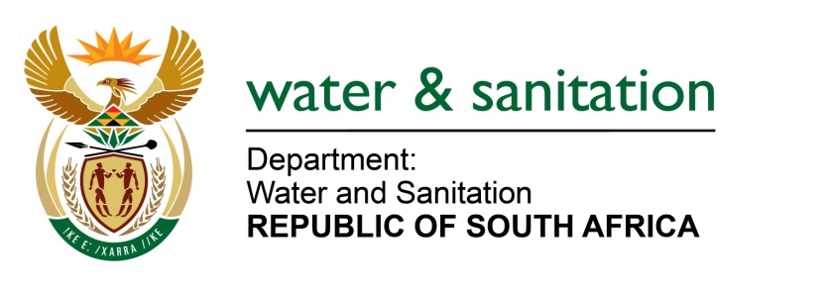

NATIONAL ASSEMBLY

FOR WRITTEN REPLY

QUESTION NO 353

DATE OF PUBLICATION IN INTERNAL QUESTION PAPER:
(INTERNAL QUESTION PAPER NO. 2) 17 FEBRUARY 2023

353. Mrs M R Mohlala (EFF) to ask the Minister of Water and Sanitation:
What (a) has been the impact of public-private partnerships with his department on the development of water and sanitation infrastructure in the Republic and (b) are the relevant details of each such public-private partnership?
NW368E
---00O00---

MINISTER OF WATER AND SANITATION
- The department has not entered into any Private Public Partnerships (PPP) as defined by the PFMA and Treasury Regulations to date.

- The department has, however, signed an agreement with the Commercial Mining Sector to jointly fund the Olifants Management Model (OMM) on a 50:50 basis. This is part of an innovative drive to collaborate with the private sector to fund public infrastructure to the benefit of all water users within a government water scheme. The Olifants River Water Resource Development Project (ORWRDP) experienced delays due to public funding constraints. and This collaboration has allowed the department to fast-track the construction of bulk and reticulation water infrastructure to supply the communities and mines by 2030. This R25 billion project started in November 2022 and is targeted for completion in 2030. The Lebalelo Water User Association is the Implementing Agent for the project. Similar collaborations are being explored in anticipation of similar benefits in other areas of the country, where local economic drivers could mutually benefit water services to local communities.

