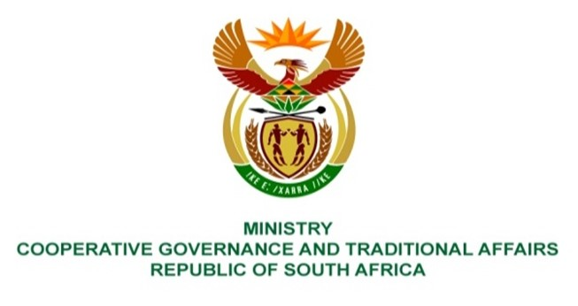

NATIONAL ASSEMBLY
QUESTION FOR WRITTEN REPLY

QUESTION NUMBER: 3524
DATE OF PUBLICATION: 30 SEPTEMBER 2022

QUESTION:

PQ 3524: Mr C Brink (DA) to ask the Minister of Cooperative Governance and Traditional Affairs:

With reference to a presentation to the Portfolio Committee on Cooperative Governance and Traditional Affairs on 21 September 2022 on the state of a section 139(7) intervention in the Manguang Metropolitan Municipality, in which her department indicated that national and provincial government departments and other organs of state owe the specified municipality about R1,3 billion in arrears, (a) what are the relevant details of each of the national and provincial departments and organs of state that owe payments to the municipality for more than 30 days as at 1 September 2022, (b)(i) what total amount is owed by each of the specified departments and organs of state and (ii) for what period of time based on an age analysis, (c) which of the debts are disputed by the relevant departments and organs of state and (d) what measures has she and/or her department taken to ensure that the maximum payment of the specified arrear debts are made as soon as possible? NW4337E

REPLY:

- National Public Works
Provincial Public Works
Schools
National Department of Rural Development and Land Reform
Free State Development Corporation

b)(i) The total amounts owed by each of the specified departments and organs of state is as follows:

Details | Debt Owed
Provincial Public Works | R 995 917 877
National Public Works | R 263 568 751
Schools | R 609 614 723
National Department of Rural Development and Land Reform | R 2 825 912
Free State Development Corporation (FDC) | R 410 137 757

b)(ii) The detailed balances and age analysis for debt owed by national and provincial departments are as follows:

Mangaung Metro | Unallocated Credit | Previous | Current | 30 Days | 60 Days | 90 Days | 120 Days | 120 Days + | Total Debt
Provincial Public Works | -87 307 544 | 33 110 974 | 0 | 29 701 878 | 29 306 915 | 27 575 747 | 27 385 429 | 663 879 362 | 723 652 761
Schools - Water only | 0 | 4 539 092 | 0 | 4 520 159 | 4 573 581 | 8 844 803 | 4 437 027 | 147 018 746 | 173 933 407
FDC | -454 590 | 5 363 353 | 0 | 4 813 283 | 3 726 426 | 10 926 322 | 4 886 103 | 385 601 951 | 414 862 848
National Public Works | -48 899 229 | 11 073 354 | 0 | 8 329 633 | 7 479 261 | 7 672 007 | 6 843 384 | 271 070 341 | 263 568 751
National Department of Land & Rural Development | -983 161 | 298 324 | 0 | 289 987 | 219 046 | 211 729 | 209 958 | 2 580 030 | 2 825 912
Total | -137 644 524 | 54 385 097 | 0 | 47 654 940 | 45 305 228 | 55 230 608 | 43 761 901 | 1 470 150 429 | 1 578 843 680
Entity Electricity - Centlec | Unallocated Credit | Previous | Current | 30 Days | 60 Days | 90 Days | 120 Days | 120 Days + | Total Debt
Provincial Public Works | 0 | 0 | 0 | 20 837 769 | 4 801 685 | 72 743 976 | 3 112 167 | 170 769 519 | 272 265 116
Schools - Water only | 0 | 0 | 0 | 33 344 802 | 7 683 703 | 4 980 120 | 4 568 427 | 385 104 263 | 435 681 317
FDC | 0 | 0 | 0 | 0 | 0 | 0 | 0 | 0 | 0
National Public Works | 0 | 0 | 0 | 0 | 0 | 0 | 0 | 0 | 0
National Department of Land and Rural Development | 0 | 0 | 0 | 0 | 0 | 0 | 0 | 0 | 0
Total | 0 | 0 | 0 | 0 | 0 | 0 | 0 | 0 | 0
 | - | - | - | 54 182 571 | 12 485 388 | 77 724 096 | 7 680 594 | 555 873 783 | 707 946 432

- National Public Works disputed an amount of approximately R 155 million.

d) Meetings have been conveed with debtors to facilitate payment of arrear debt to the Metro including the issuance of letters of demand reflecting amounts outstanding on their municipal accounts.

