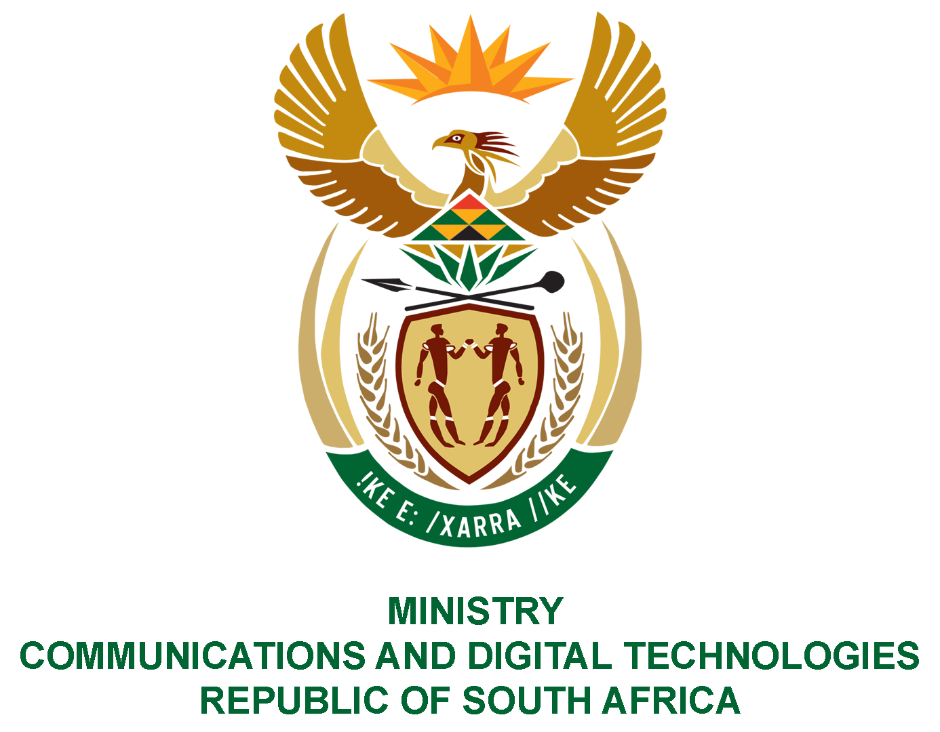

PARLIAMENT OF THE REPUBLIC OF SOUTH AFRICA
NATIONAL ASSEMBLY
WRITTEN REPLY

QUESTION NO: 352
DATE OF PUBLICATION: 6 MARCH 2020
QUESTION PAPER NO:7

Ms P T van Damme (DA) to ask the Minister of Communications:
- On what date will the revised SA Broadcasting Corporation Editorial Policy be published;
- Whether there will be an opportunity for further public consultation once the revised policy is published; if not, what is the position in this regard; if so, what are the relevant details;
- What are the reasons for the delay in the process of the review of the policy? NW507E
REPLY
I have been advised by SABC as follows:
- The SABC has notified the public of the revised Editorial Policies on 3 July 2020.
- No, there is no further public consultation. There were two stages of public consultations torevise the Editorial Policies.The first stage commenced on 31 July 2017 and closed on 29 September 2017. The second stage of consultations was on the developed draft policies which commenced on 23 July 2018 and closed on 31 August 2018. However, when the Commission of Inquiry was established it was felt that there might be valuable information in the report that could be incorporated into the Editorial Policies. Should that have been the case, the policy would have been published again for input.

- The review process was delayed by the establishment of a Commission of Inquiry into interference in the decision-making in the Newsrooms, led by Joe Thloloe. The outcome or findings of this commission could have affected the policy, hence the SABC deemed it prudent to await its outcomes. Now that the report has been released and no additional information has been added to the Editorial Policy and all internal governance processes have been completed, same will be published.

MS STELLA NDABENI-ABRAHAMS, MP
MINISTER OF COMMUNICATIONS AND DIGITAL TECHNOLOGIES

