FOR WRITTEN REPLY

NATIONAL ASSEMBLY
36/1/4/1(201900039)

QUESTION 352

DATE OF PUBLICATION IN INTERNAL QUESTION PAPER: 22 FEBRUARY 2019 (INTERNAL QUESTION PAPER NO 3-2019)

352. Mr M S F de Freitas (DA) to ask the Minister of Police:

With reference to the charges laid against the Passenger Rail Agency of South Africa or any individuals connected to this state-owned entity, (a) what investigations have been initiated to date, (b) on what date was each investigation initiated, (c) what is the name of each investigating officer who has been allocated to each case and (d) what progress has been made in each case to date?

REPLY:
NW376E

- Number of case dockets under investigation:
- Hillbrow, CAS 405/07/2015 - Fraud and Corruption.
- Brooklyn, CAS 564/12/2017 - Fraud and Corruption.
- Brooklyn, CAS 605/10/2017 - Fraud and Corruption.
- Brooklyn, CAS 562/12/2017 - Fraud and Corruption.
- Brooklyn, CAS 278/09/2015 - Fraud and Corruption.

- Dates on which each investigation was initiated:

1. Hillbrow, CAS 405/07/2015 | - 2015-07-08.
2. Brooklyn, CAS 564/12/2017 | - 2017-12-07.
3. Brooklyn, CAS 605/10/2017 | - 2017-10-25.
4. Brooklyn, CAS 562/12/2017 | - 2017-11-29.
5. Brooklyn, CAS 278/09/2015 | - 2015-09-10.

- The particulars of the investigating officers cannot be divulged, to ensure that the cases are investigated without fear or favour.

- Progress made in each case to date: Hillbrow, CAS 405/07/2015:

The matter is still under investigation. A total of 250 statements were obtained and case plan meetings with prosecutors, who are allocated to the case, are held on a monthly basis.

2. Brooklyn, CAS 564/12/2017:
Allegations contained in this matter are the same as those in Hillbrow, CAS 405/07/2015.

3. Brooklyn, CAS 605/10/2017:
Allegations contained in this matter are the same as those in Hillbrow, CAS 405/07/2015.

4. Brooklyn, CAS 562/12/2017:
The matter is under investigation. It was referred to the Directorate for Priority Crime Investigation (DPCI), in December 2018, from the Provincial Detectives, in Gauteng. The complainant is to be interviewed in order to proceed with the investigation. The investigator has been analysing the audit report, identifying the potential witnesses and compiling an investigation plan.

5. Brooklyn, CAS 278/09/2015:
The matter is under investigation. To date, 90 statements have been obtained and case plan meetings with prosecutors, allocated to the case, are held on a monthly basis.

Reply to question 352 recommended/

ION COM
KJ (SOEG)

GENERAL ER: UT AFRICAN POLICE SERVICE

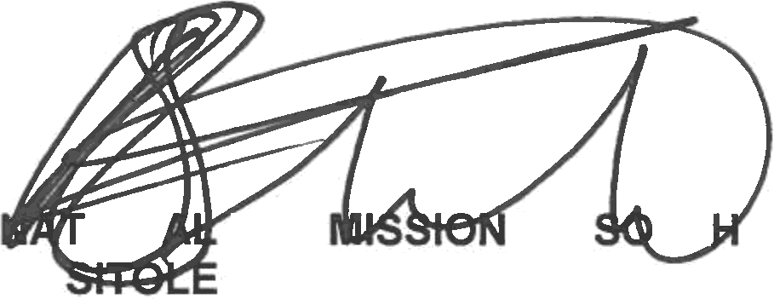
Date: ›019 » »

Reply to question 352 approved/not approved

MINISTER OF POLICE
BH CELE, MP

Date:

