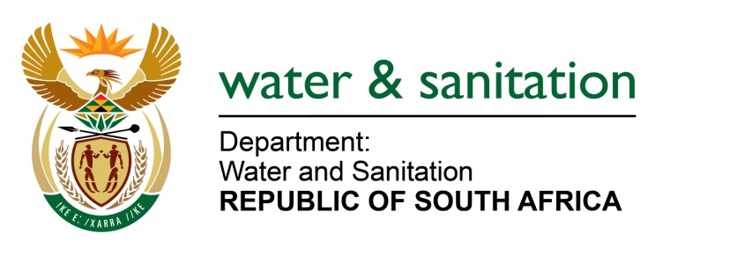

NATIONAL ASSEMBLY

FOR WRITTEN REPLY

QUESTION NO 3501

DATE OF PUBLICATION IN INTERNAL QUESTION PAPER: 3 NOVEMBER 2017
(INTERNAL QUESTION PAPER NO. 41)
3501. Mr D R Ryder (DA) to ask the Minister of Water and Sanitation:
(1) What is the current status of the construction of the Rietspruit Outfall Sewer Pipeline in Midvaal and Emfuleni which is currently threatening the construction of houses in Savanna City;
(2) has a contractor been appointed; if not, (a) why not and (b) by what date will a contractor be appointed; if so, what are the relevant details;
(3) what is the planned completion date of the project? NW3928E

---00O00---
REPLY:
(1) Rietspruit Outfall Sewer Pipeline project has recently been incorporated into the Sedibeng Regional Sewer Scheme (SRSS) based on the recommendation of the SRSS Technical Feasibility Study review. Risimati Consulting Engineers Pty (Ltd) were appointed by Emfuleni Municipality before the project was incorporated into the SRSS and to date, about 50% of the detail design of the sewer pipeline has been completed. Since the project is now part of the SRSS and Rand Water is the Implementing Agent for SRSS, the Risimati contract is to be ceded to Rand Water. Currently the due diligence exercise is underway at Rand Water, and it is about 90% complete.
(2) No, the contractor has not yet been appointed. Once the Rasimati Consulting Engineers have completed the detail design of the sewer outfall pipeline, then a competent contractor to do the construction work will be appointed following Rand Water’s procurement process.
(3) Subject to availability of funds, the Rietspruit Outfall Sewer pipeline project will commence in the next financial year, and will run for a period of 3 years.
---00O00---

