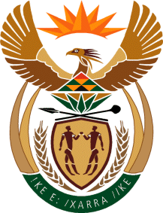

Ministry
Employment & Labour
Republic of South Africa
Private Bag X499, PRETORIA, 0001. Laboria House 215 Schoeman Street, PRETORA Tel: (012) 392 9620 Fax: 012 320 1942
Private Bag X9090, CAPE TOWN, 8000. 120 Plein Street, 12th Floor, CAPE TOWN Tel: (021) 466 7160 Fax 021 432 2830
www.labour.gov.za

NATIONAL ASSEMBLY

WRITTEN REPLY

QUESTION NUMBER: 35 [NW37E]

35. Ms C N Mkhonto (EFF) to ask the Minister of Employment and Labour:
Whether his department has done any investigations into the adherence of employers to labour laws during the lockdown to curb the spread of COVID-19; if so, has he found that employers adhered to the specified laws in the manner that they treat the workers during the lockdown? NW37E
REPLY:
The Occupational Health and Safety inspectors, nationally, conducted around 18 238 inspections for the three quarters in the financial year 2020/21. 47% of workplaces inspected were found to be non-compliant whilst 53% were found to be compliant with OHS and COVID19 Directions.
Around 8619 notices were issued to non-compliant employers during this period. This included contravention, prohibition and improvement notices.

