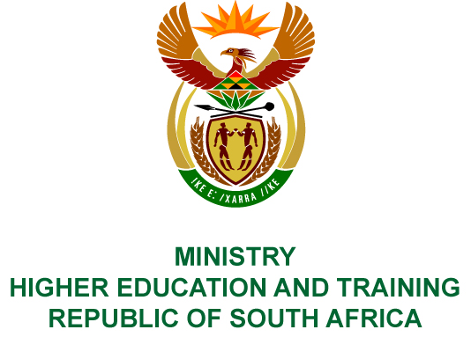
Private Bag X893, Pretoria, 0001, Tel (012) 312 5555, Fax (012) 323 5618
Private Bag X9192, Cape Town, 8000, Tel (021) 469 5150, Fax: (021) 465 7956
Memorandum from the Parliamentary Office
NATIONAL ASSEMBLY
FOR WRITTEN REPLY
QUESTION 35
DATE OF PUBLICATION OF INTERNAL QUESTION PAPER: 08/02/2018

(INTERNAL QUESTION PAPER NO 1 OF 2018)
Mr D Bergman (DA) to ask the Minister of Higher Education and Training:
With reference to her reply to oral question 190 on 1 November 2017 and her department’s report to the Portfolio Committee on Higher Education and Training on 22 November 2017, that the forensic report on the Intellimali matter at Walter Sisulu University that was due on 3 November 2017 had been received by her department but was inconclusive, (a) by what date will her department’s own report on the matter be completed, (b) what are the terms of reference of the envisaged departmental inquiry and (c) will a criminal complaint be laid as a result of the findings?
NW40E

REPLY:
- The report will be completed on 15 April 2018.
- The scope of the investigation should peruse all relevant agreements, processes, procedures and policies at the National Student Financial Aid Scheme (NSFAS), Walter Sisulu University (WSU) and the service provider, Intellimali, to determine how this erroneous payment was processed. The scope of the review should examine all investigations pertaining to this matter that were undertaken by NSFAS, WSU and Intellimali, and interview all relevant parties as deemed appropriate.
- A criminal case will be brought against any person who has broken the law if identified by the forensic investigation.

