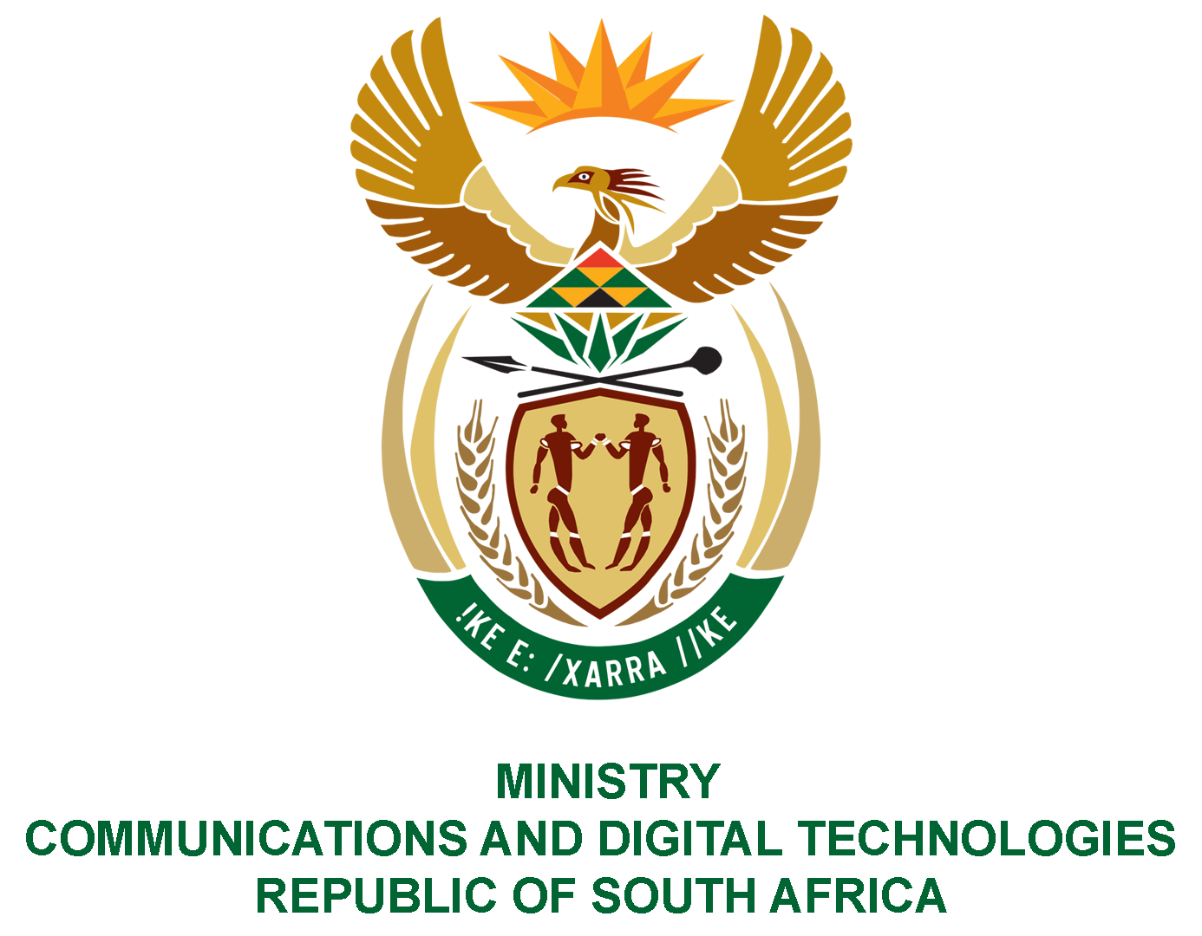
PARLIAMENT OF THE REPUBLIC OF SOUTH AFRICA
NATIONAL ASSEMBLY
WRITTEN REPLY

QUESTION NO: 3497
DATE OF PUBLICATION: 30 SEPTEMBER 2022
I QUESTION PAPER NO: 37

Ms D Kohler (DA) to ask the Minister of Communications and Digital Technologies:
Whether she will furnish Ms D Kohler with (a) a complete list of the (i) names and (ii) addresses of the branches of the SA Post Office (SAPO) that she has decided to close and (b) the reasons for the closure of each specified branch; if not, why not; if so, what are the relevant details? NW4310E

REPLY:
- The Minister of Communications and Digital Technologies did not decide to close any post office branch.

Authorised for submission by

_______________
MS. NONKQUBELA JORDAN-DYANI
DIRECTOR-GENERAL (ACTING)
DATE:

Recommended/not recommended

_______________________________
HON. PHILLY MAPULANE, MP
DEPUTY MINISTER OF COMMUNICATIONS AND DIGITAL TECHNOLOGIES
DATE:

Approved/ not approved

___________________________________
HON. KHUMBUDZO NTSHAVHENI, MP
MINISTER OF COMMUNICATIONS AND DIGITAL TECHNOLOGIES
DATE:

